MODULE 1 :- AWS CLOUD
AWS FUNDAMENTALS
SUBMITTED BY :- CHANDAN YADAV KS
SUBMITTED TO :- VIKUL
DATE OF SUBMISSION :- 30-04-2025

1.L1 - Demonstrate the AWS EC2 Ubuntu Instance Creation steps and connect to EC2 Instance using Mobaxterm/putty agent
STEP 1: Login to AWS Console
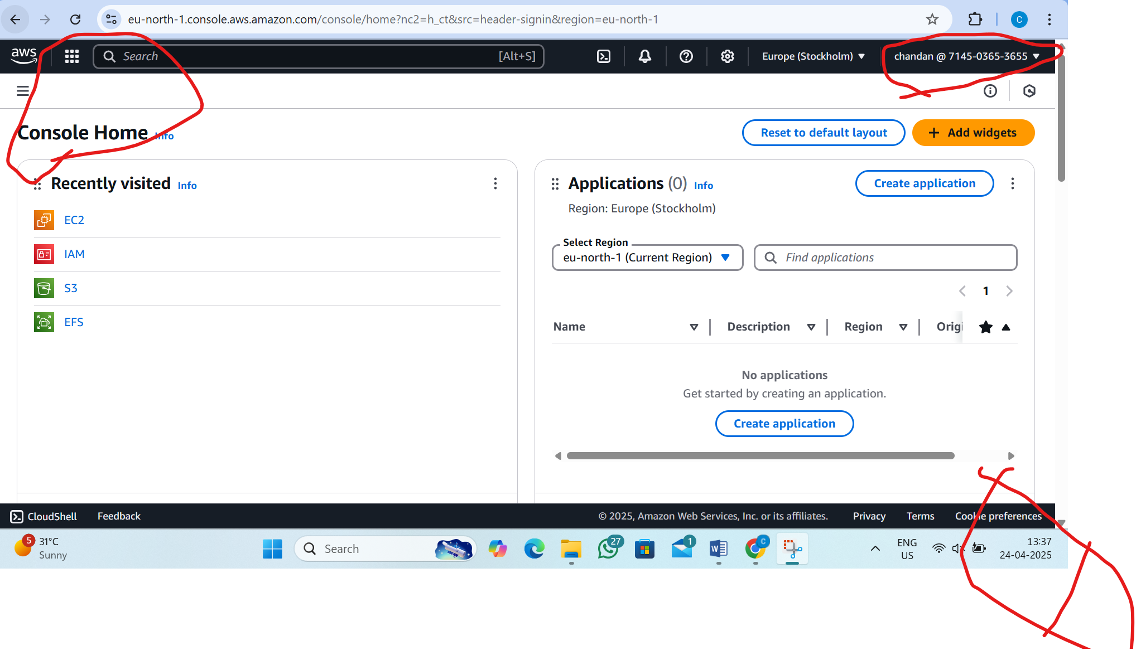

STEP 2:- Go to EC2 Dashboard

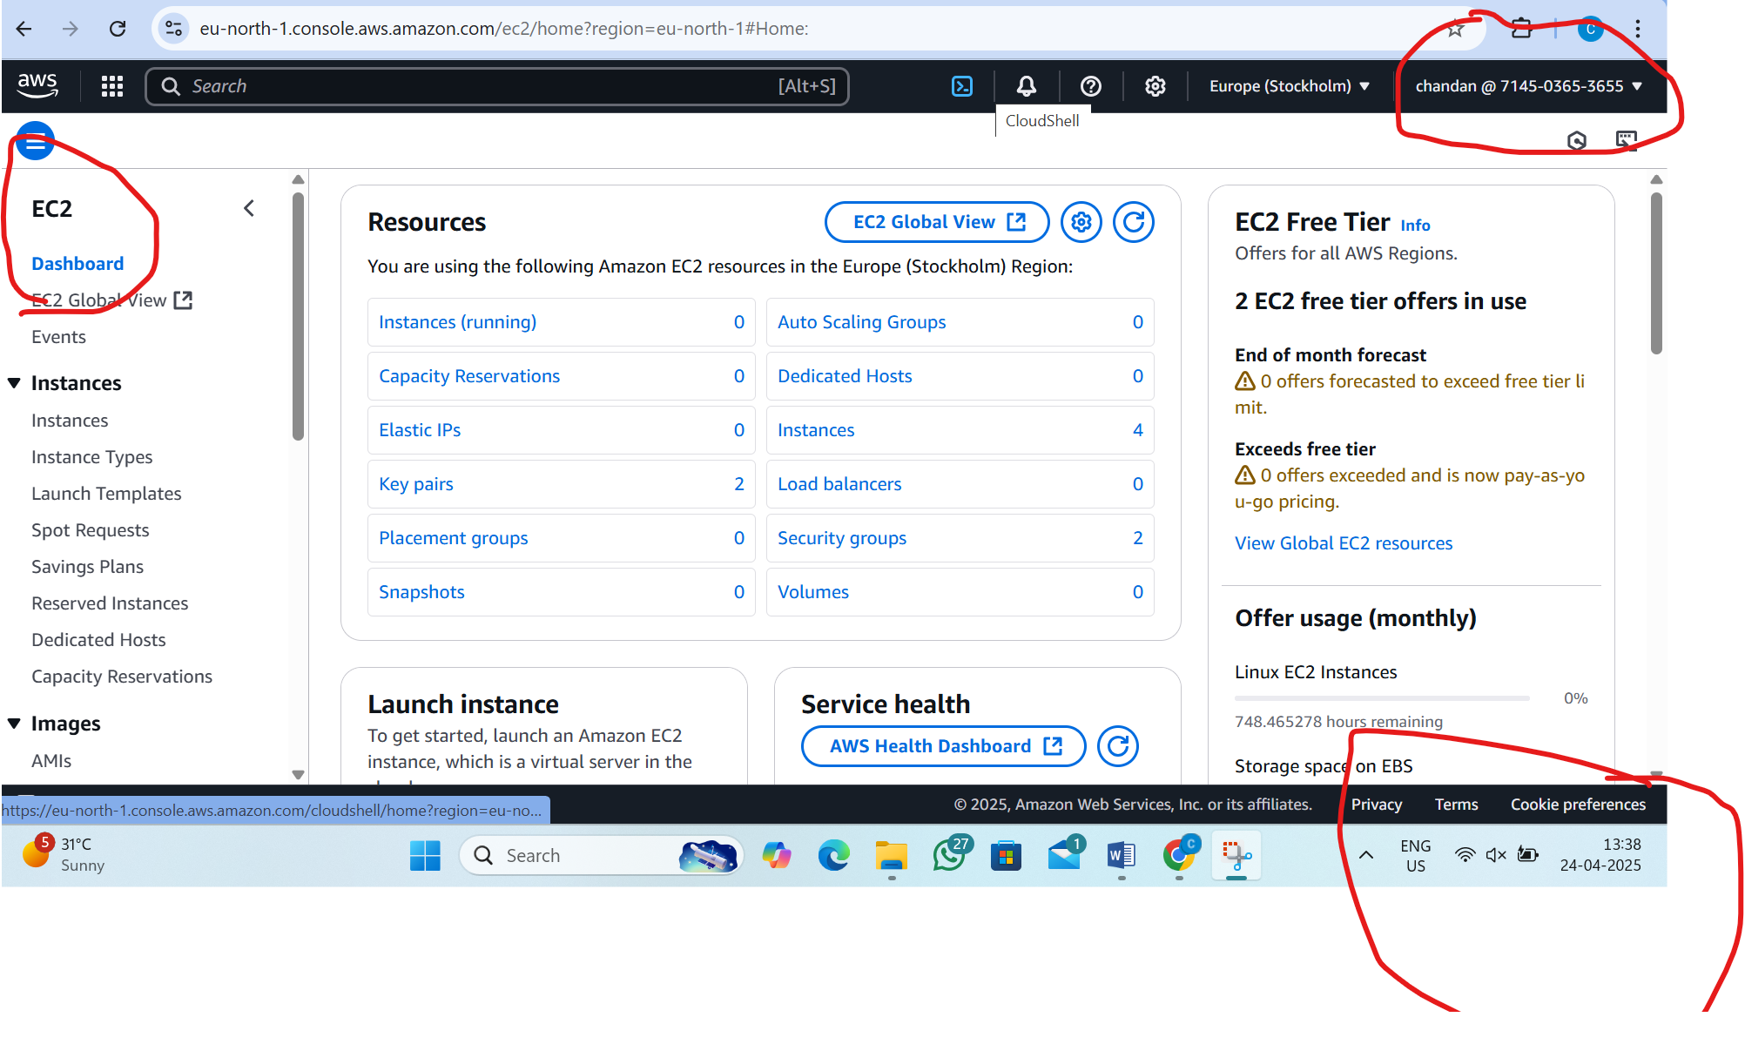
STEP 3:- Configure Instance Details

i) Launch instance
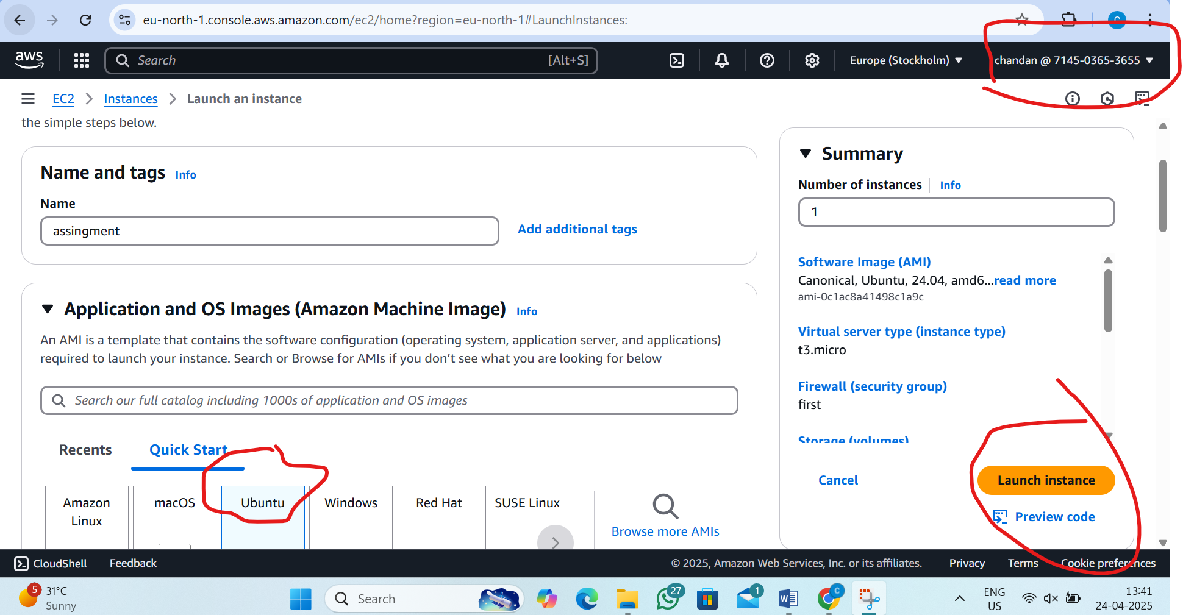

ii)New Instance is created
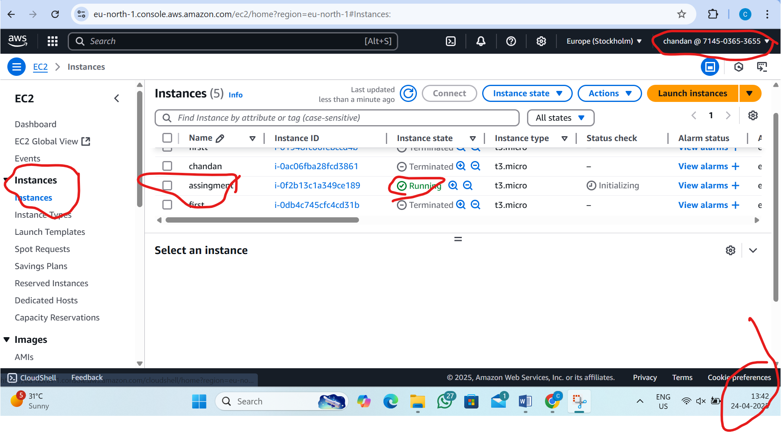

STEP 4:- View Instance
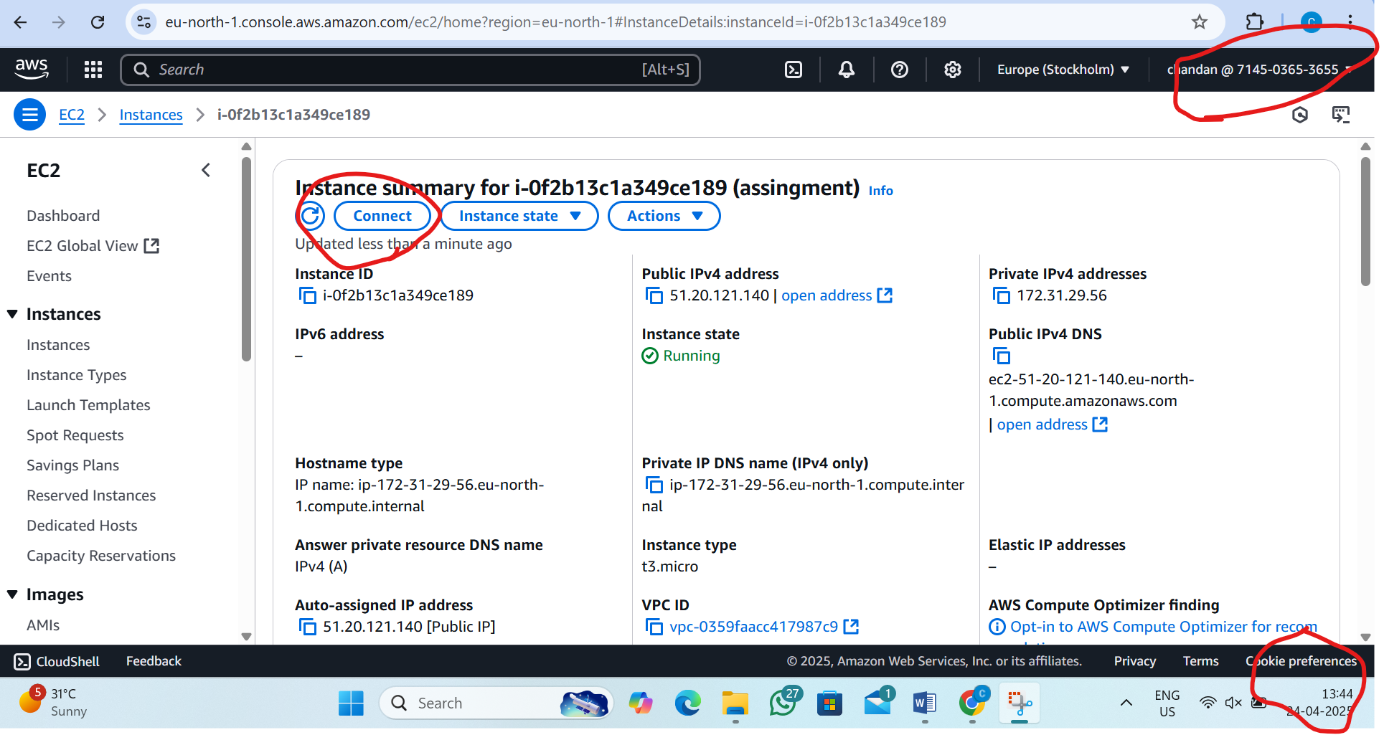

STEP 5:-connecting the server remotly
i)Go to connect instance and there click SSH client
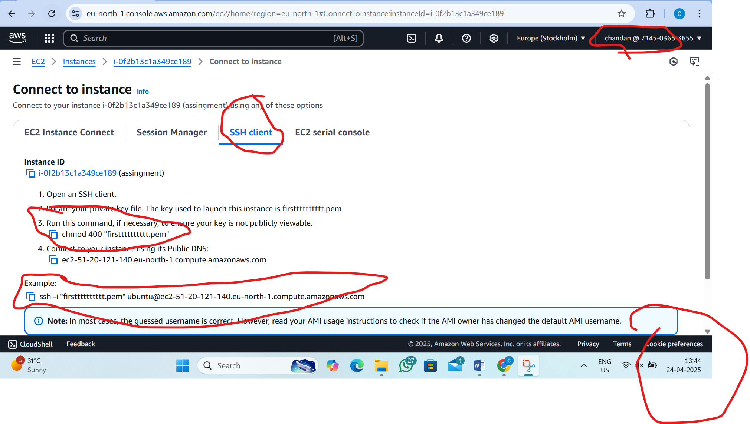

ii)running the server in Mobaxterm
(copy the 3rd command in ssh and copy the example command in ssh use in Mobaxterm run the server)

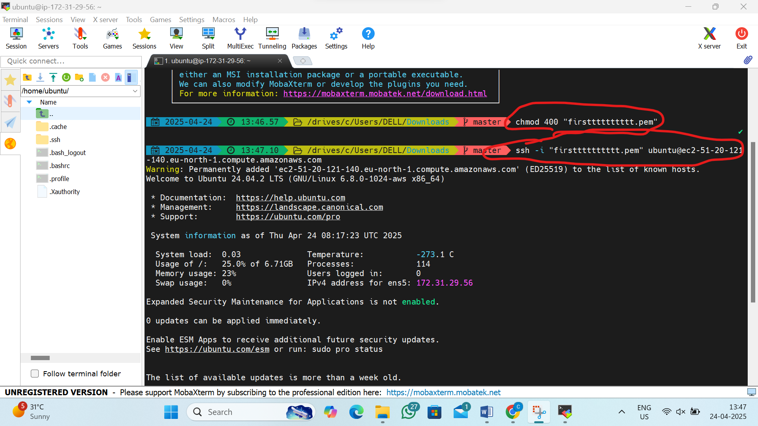

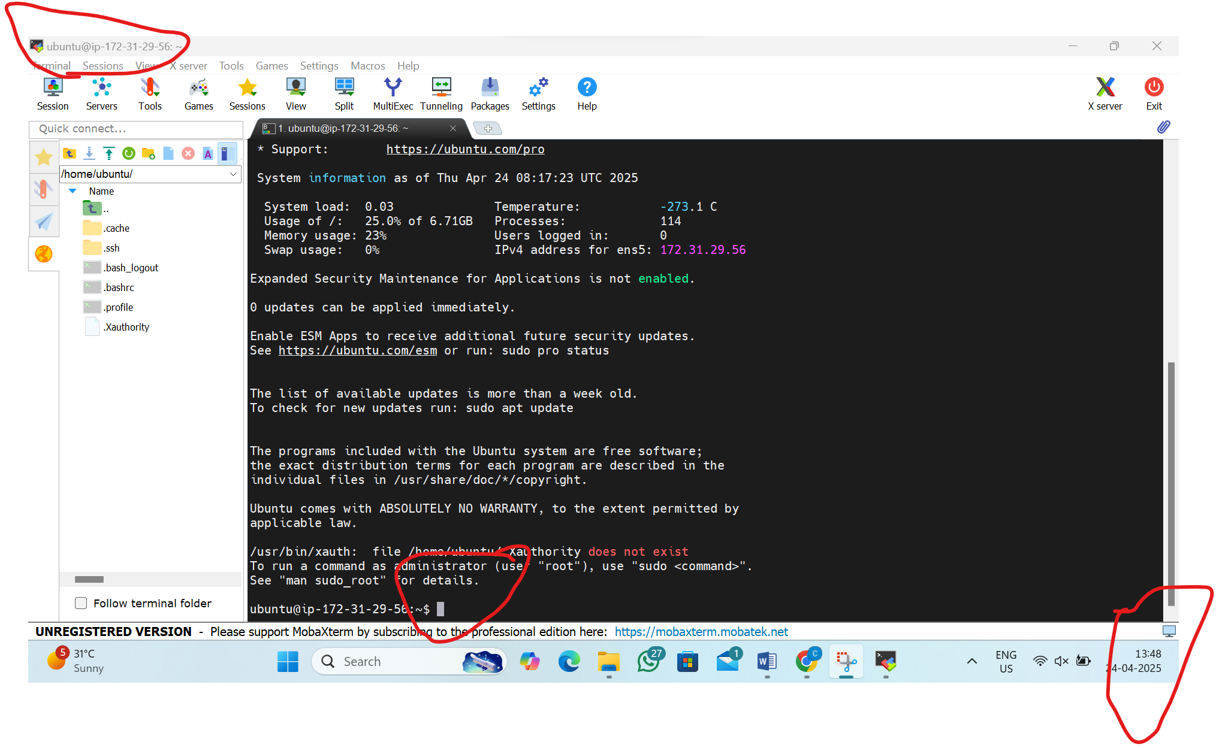
2. L2 - Login to AWS Console and Create IAM User, Role, and Group

STEP 1: Login to AWS Console
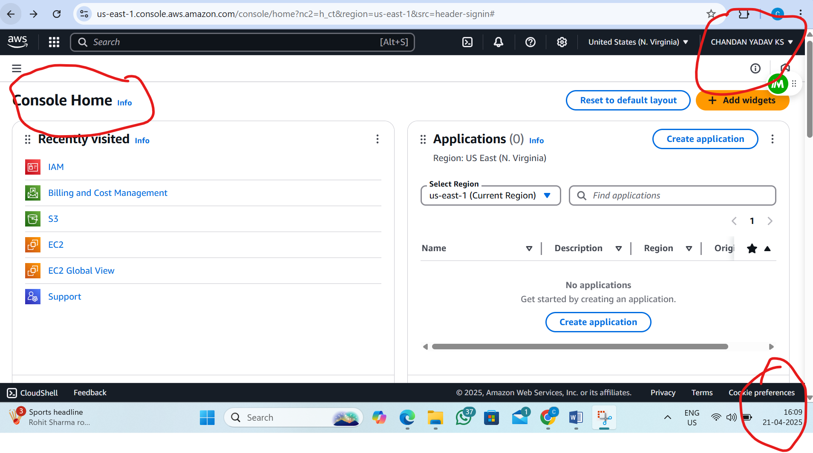

STEP 2: Go to IAM (Identity and Access Management) (Dashboard)
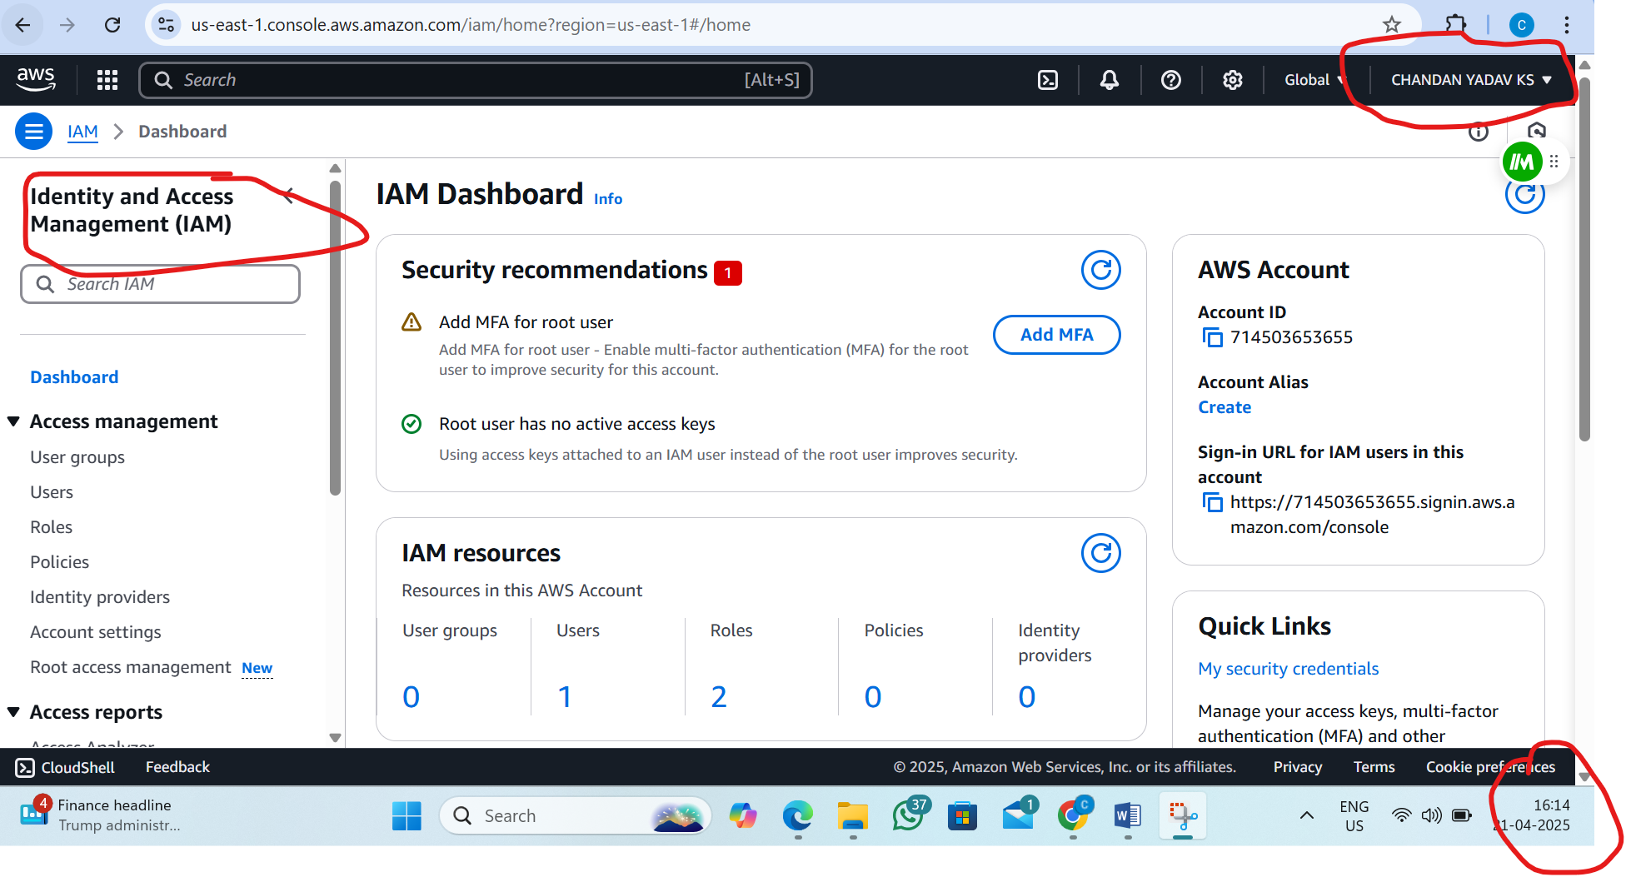
STEP 3: Create an IAM User Group

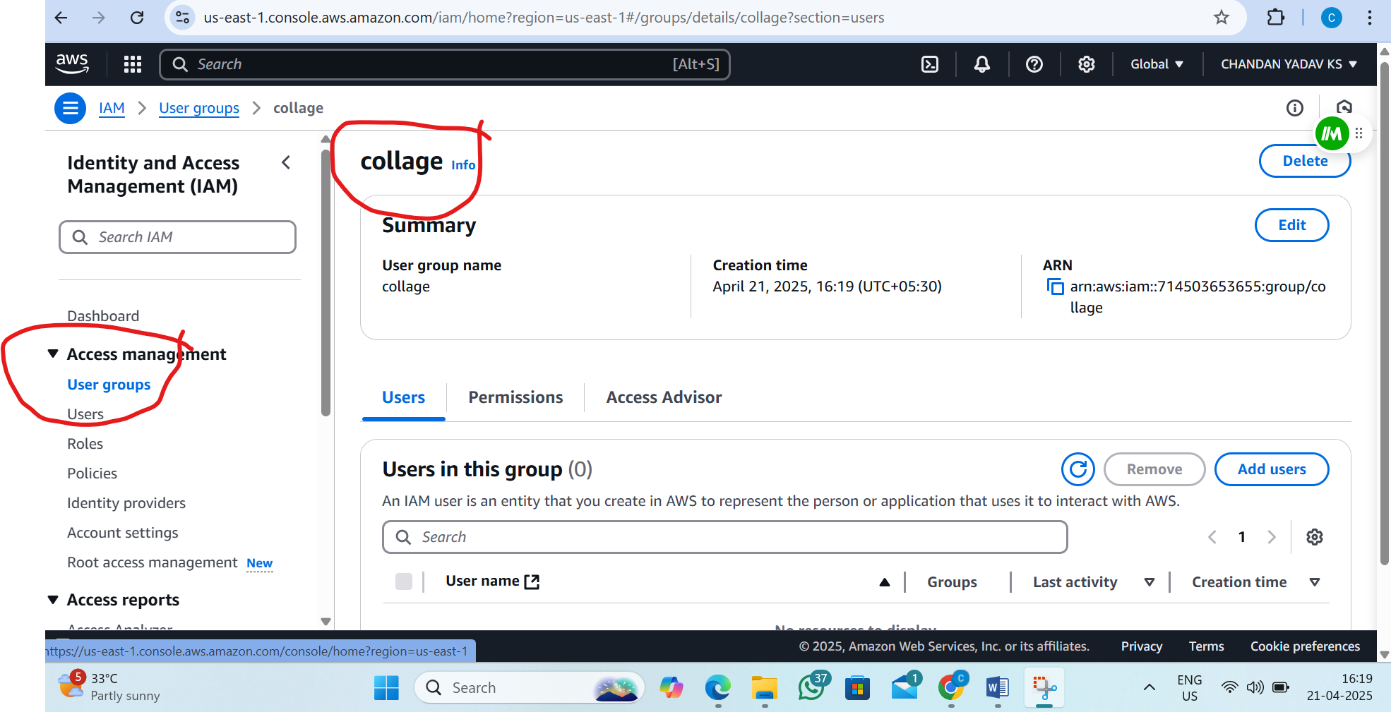

STEP 3: Create an IAM User

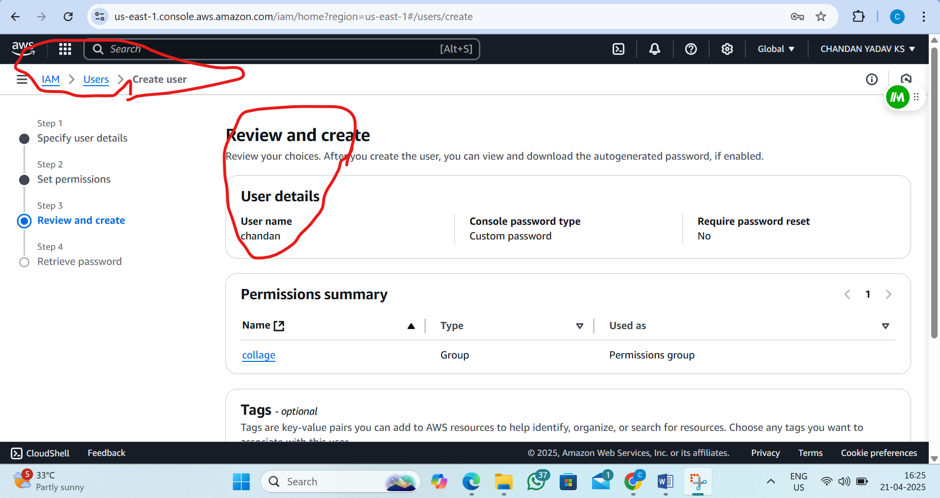
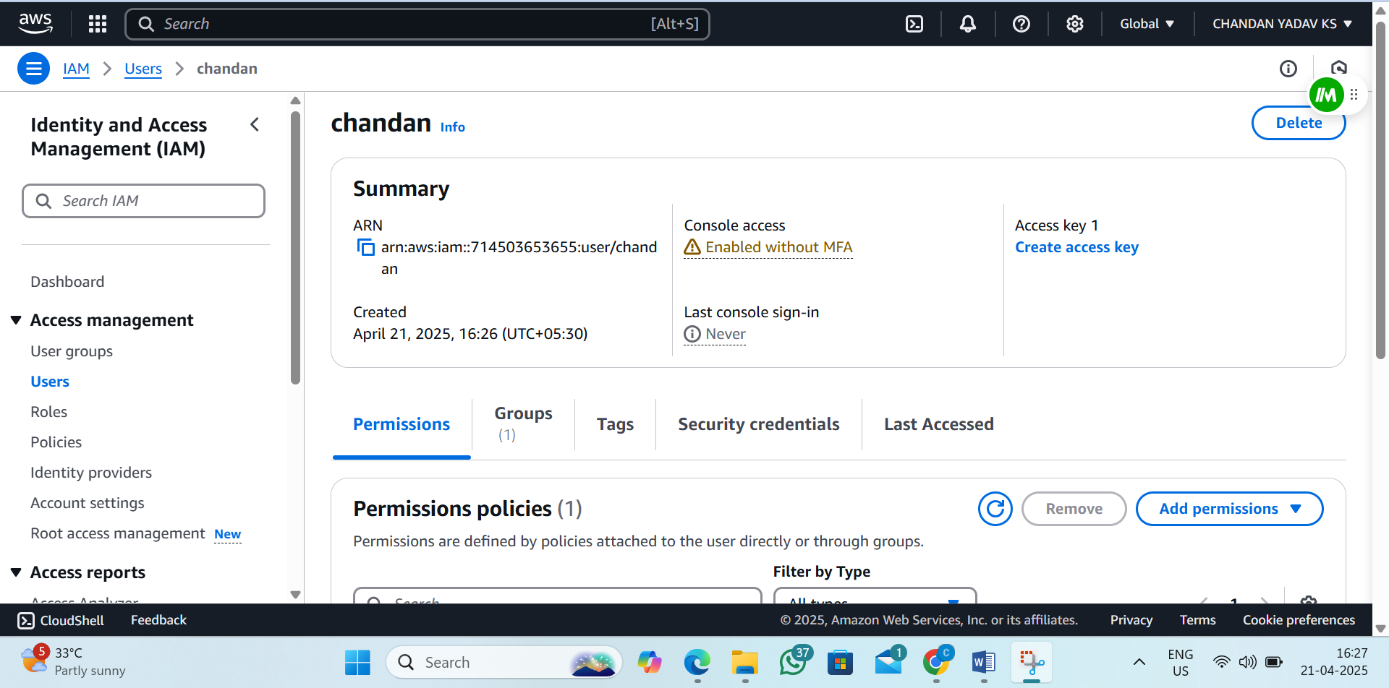

STEP 4: Create an IAM Role (maximum duration is 1 hour)

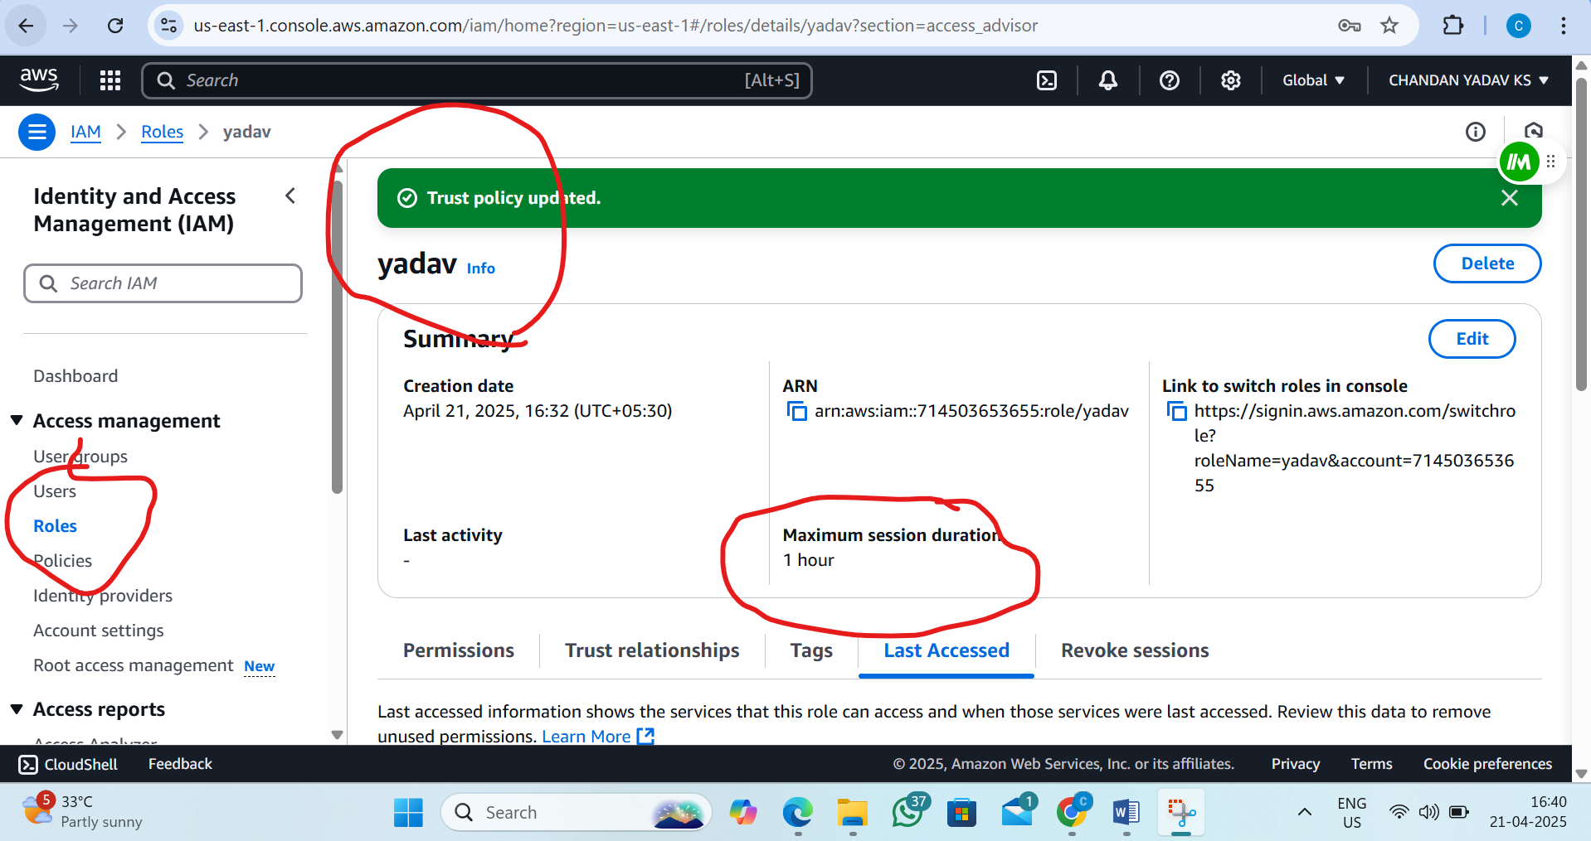

STEP 4: Attach the role to user
i) copy arn in user
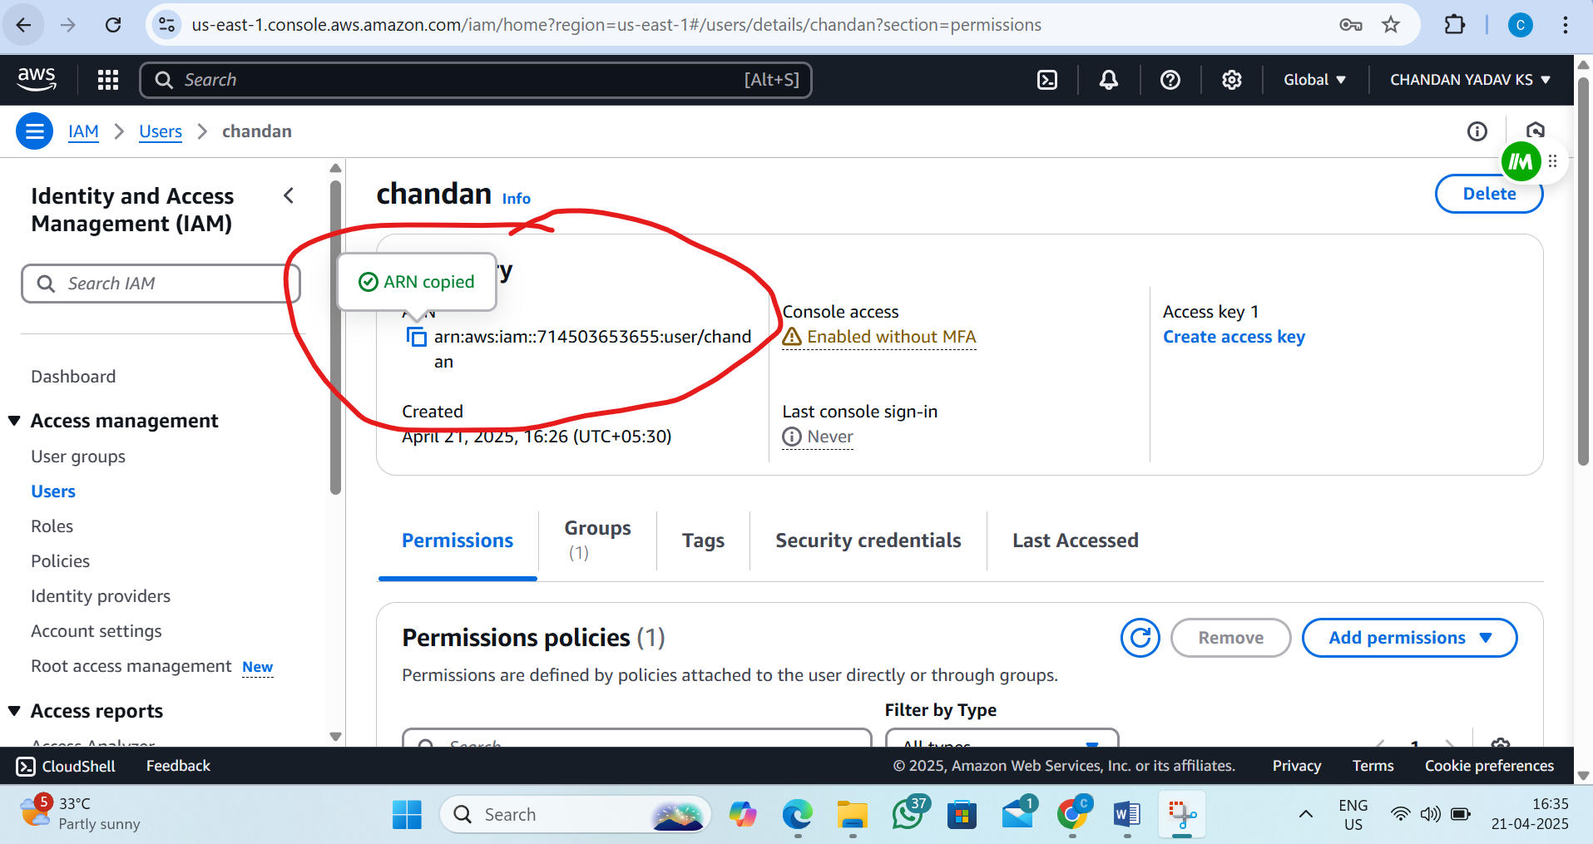

ii)Edit the trust Relationship in role (paste the arn of user )
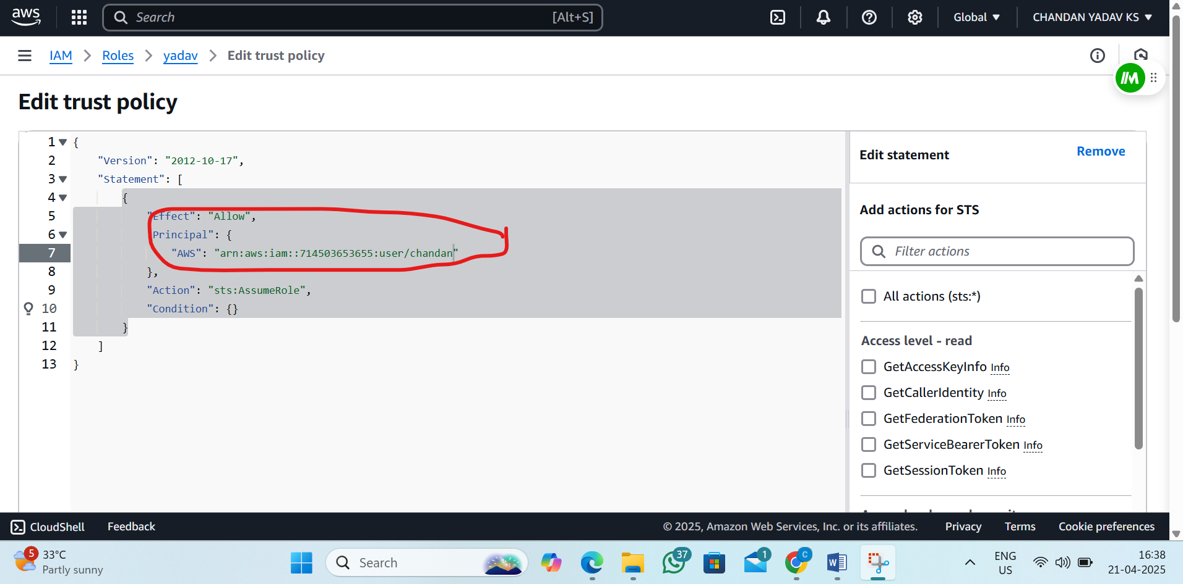

3. L3 - Launch AWS EC2 Ubuntu Instance and configure the Security Group - Inbound Rule: 8080. Justify the usage of Inbound Rules
STEP 1: Login to AWS Console
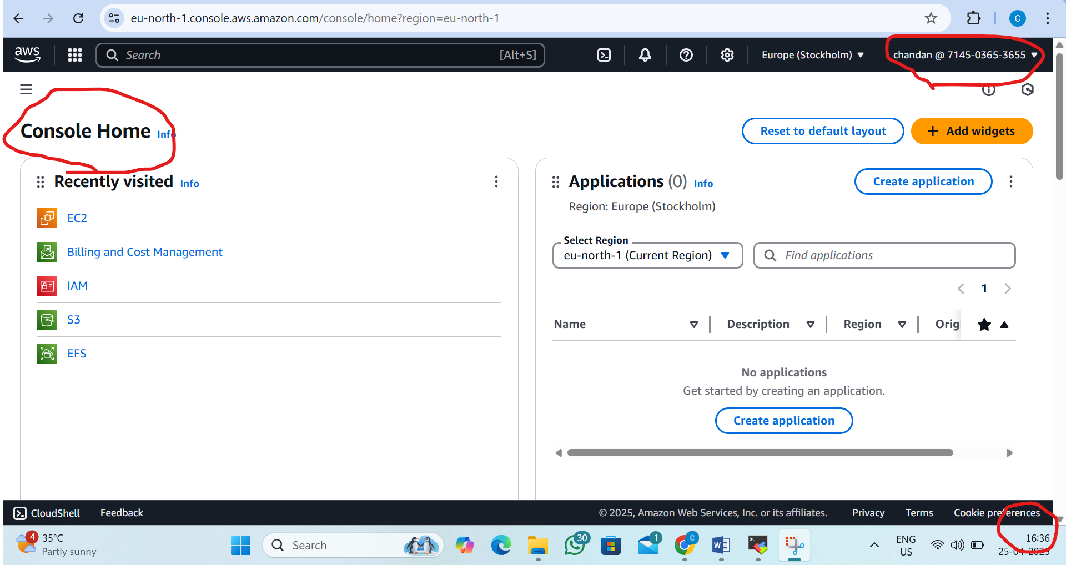
EC2 dashboard
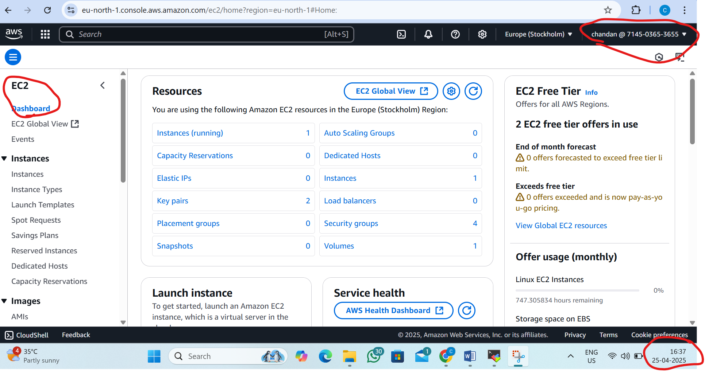

Step 2:Security group to create Inbound rule
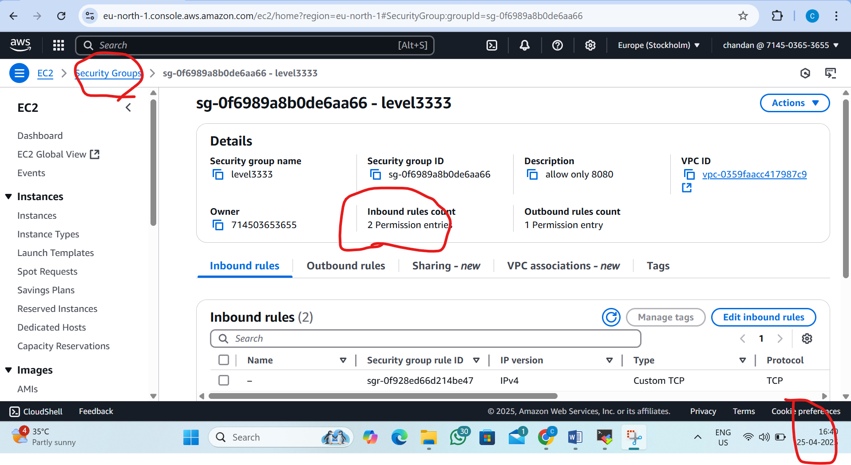

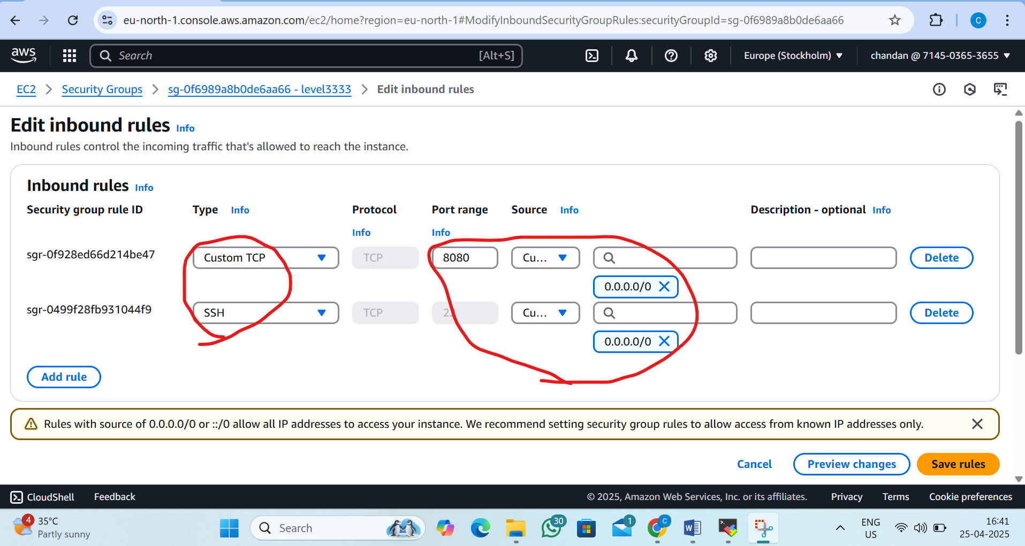

Step 3:Create EC2(Ubantu)
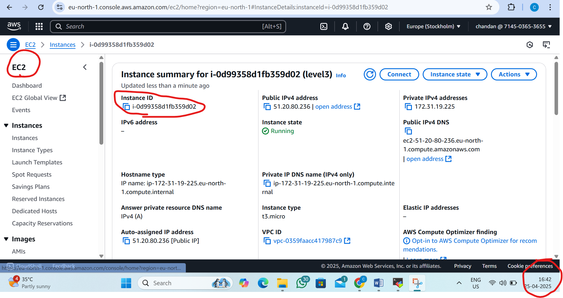
SSH client
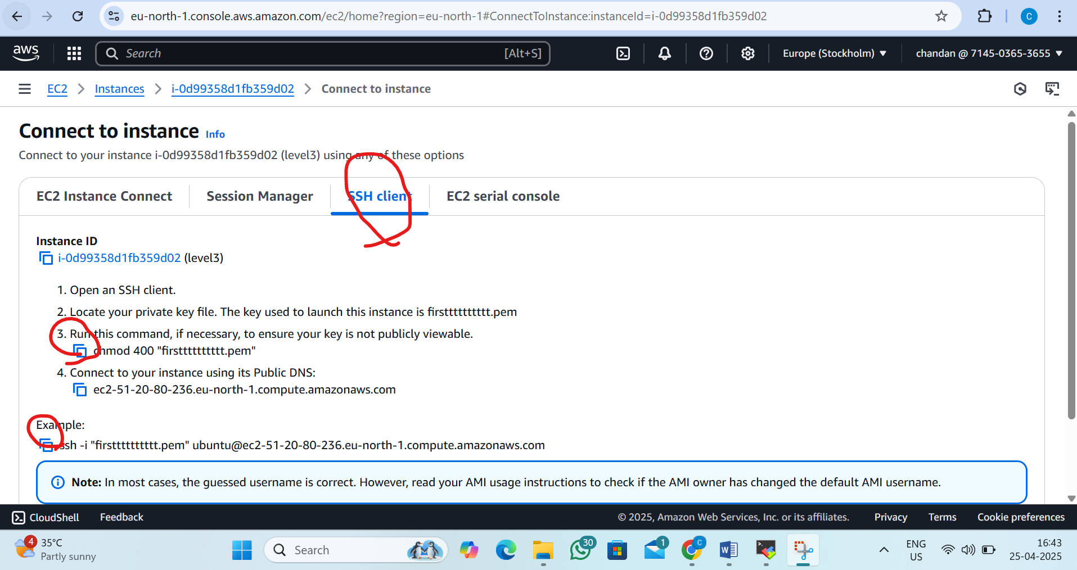

Step 4:Connect Ec2 instance
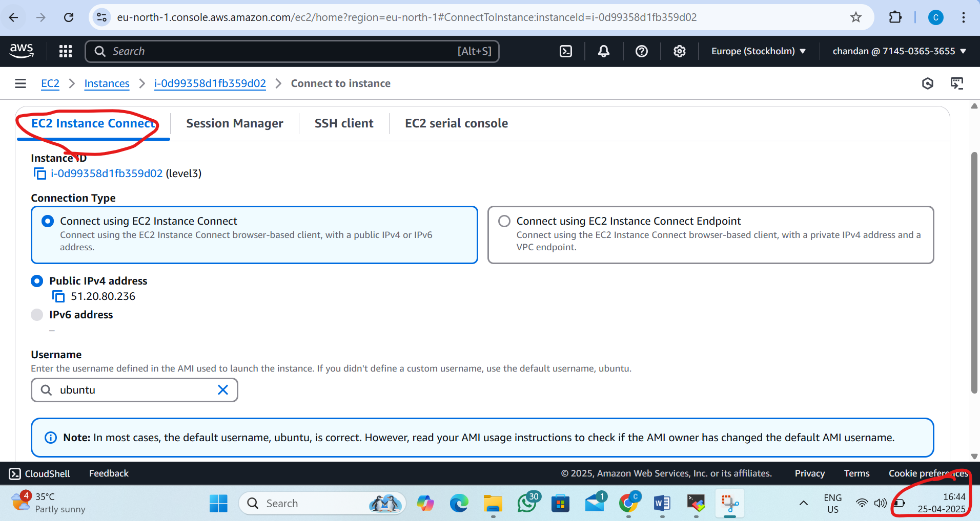

Step 5:Ubuntu Ec2 sever is Lunched
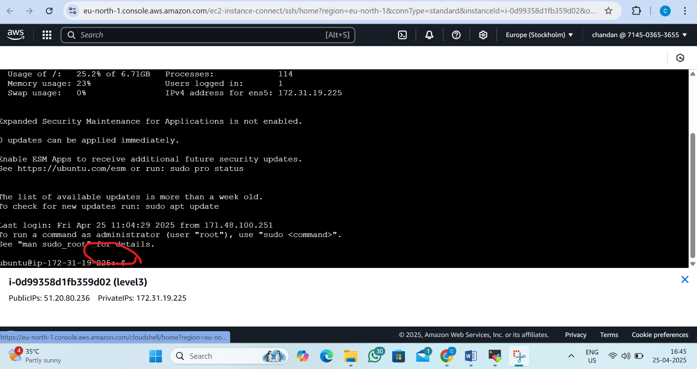

L4 - Connect to the AWS EC2 Ubuntu Instance and Update default packages, install JDK, Maven, Git, and validate the versions

Step 1:Connecting aws EC2 Ubuntu instance
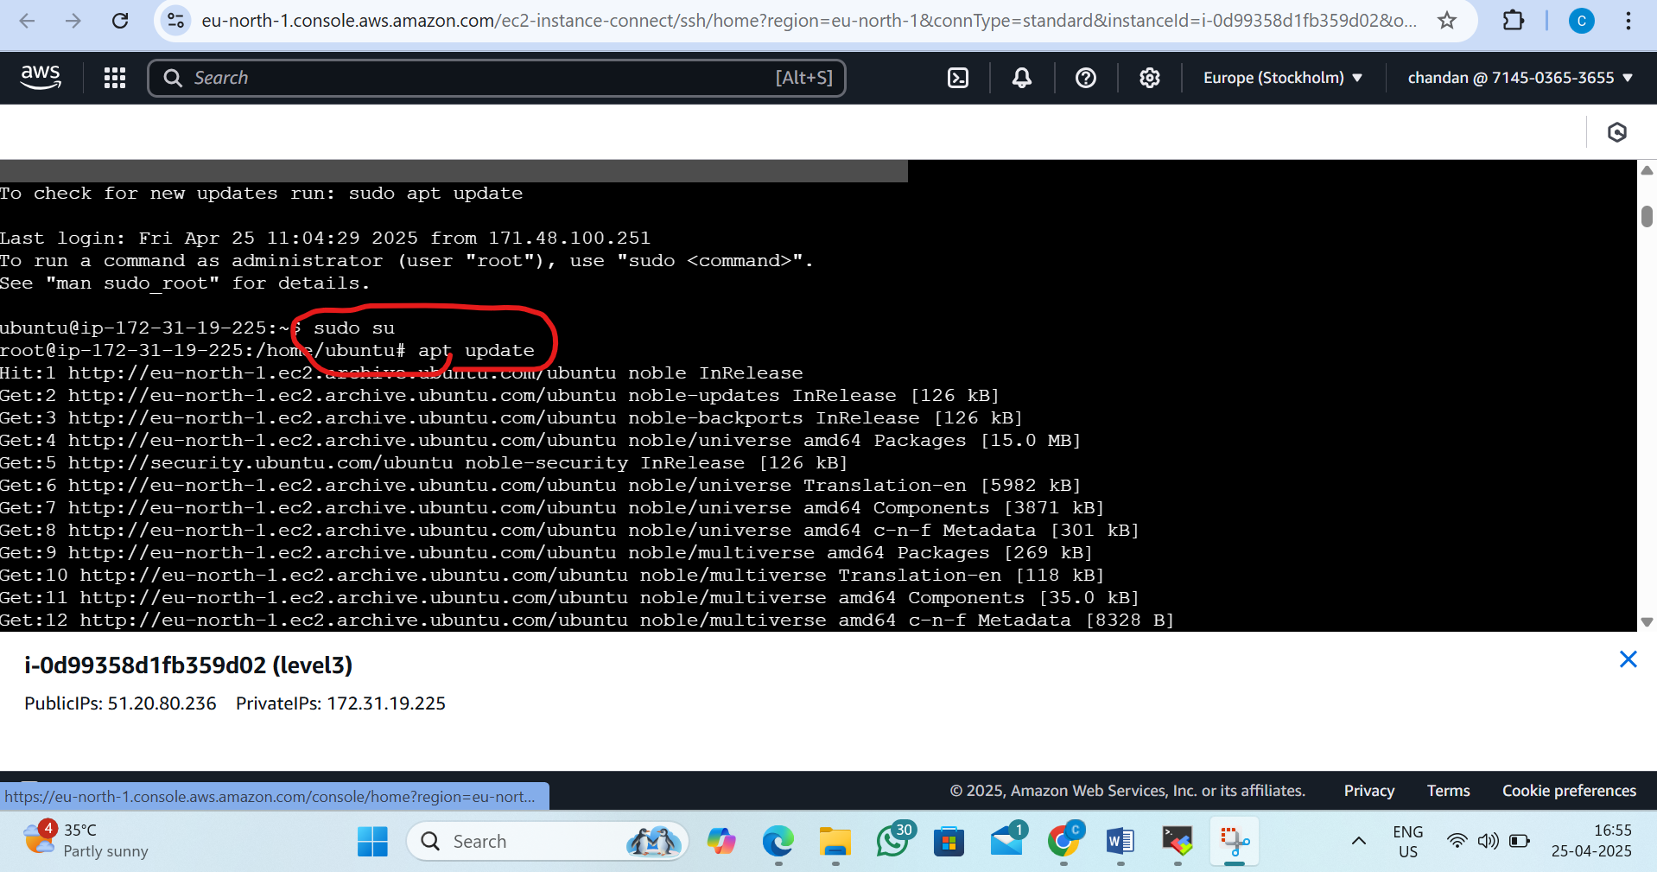
Step 2:Check the java version
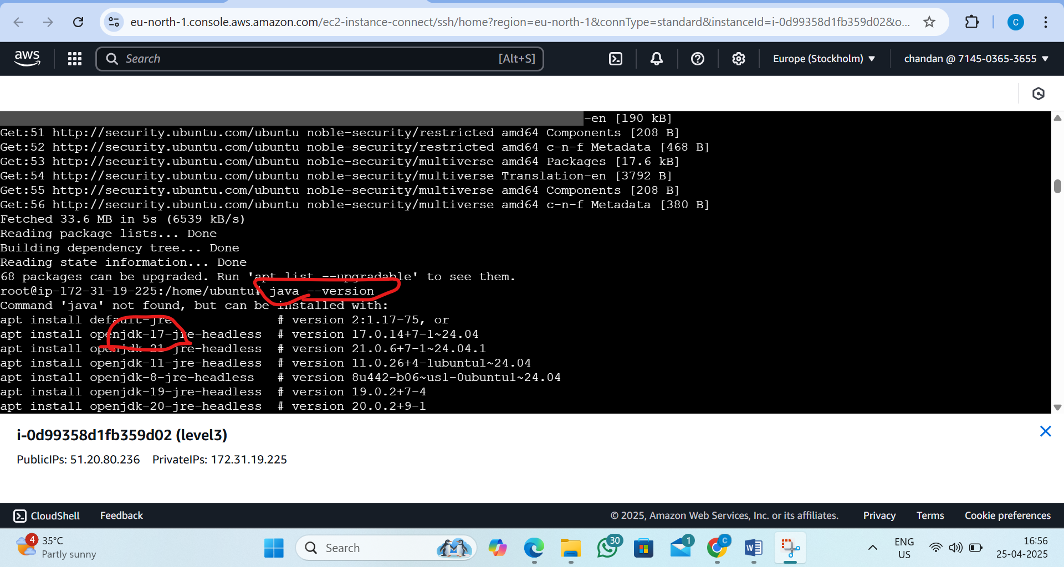

Step 3:Install the Java 17 version
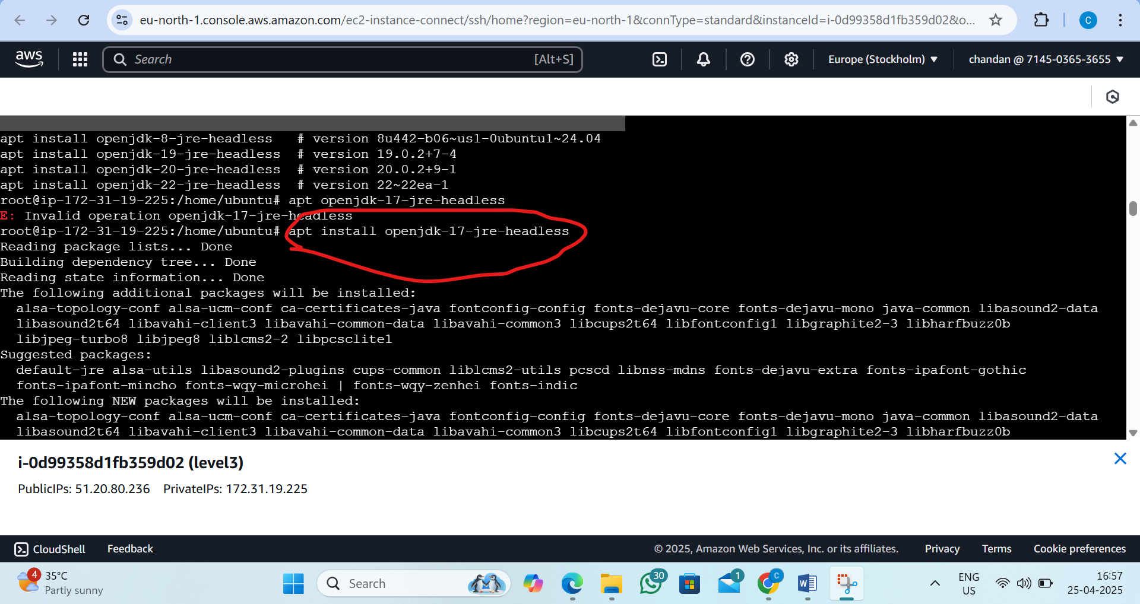

Step4:Java version is installed
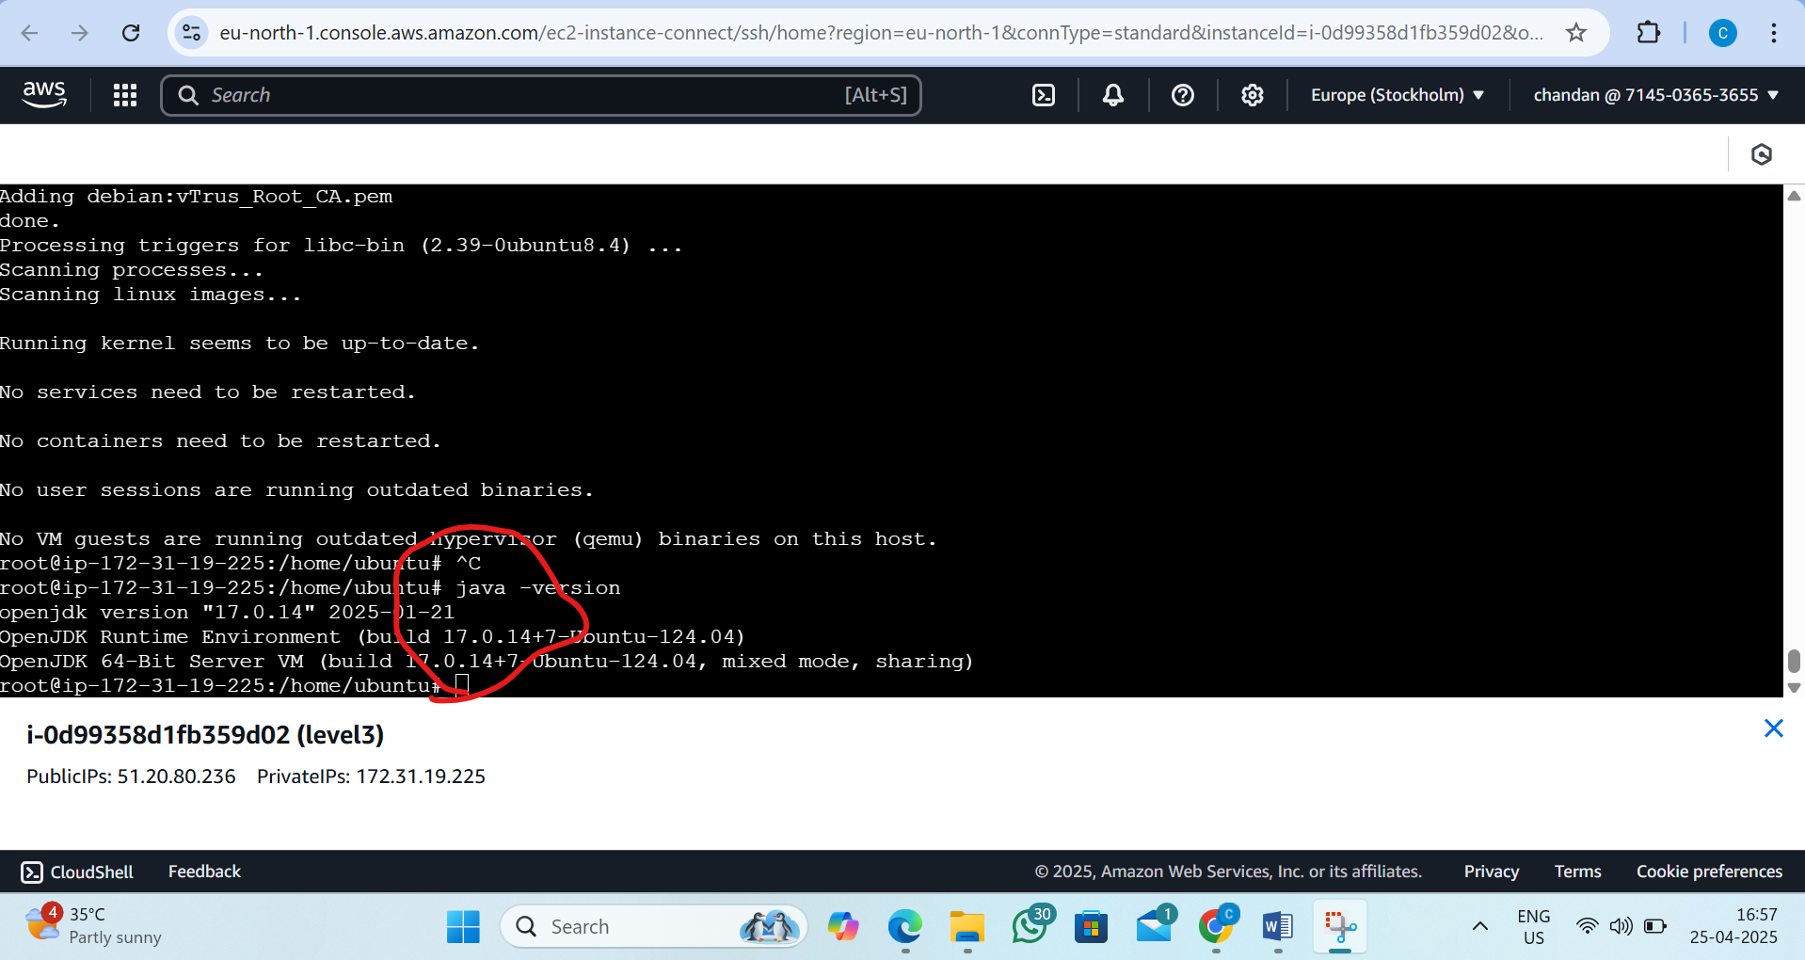

Step5:Install the Maven version
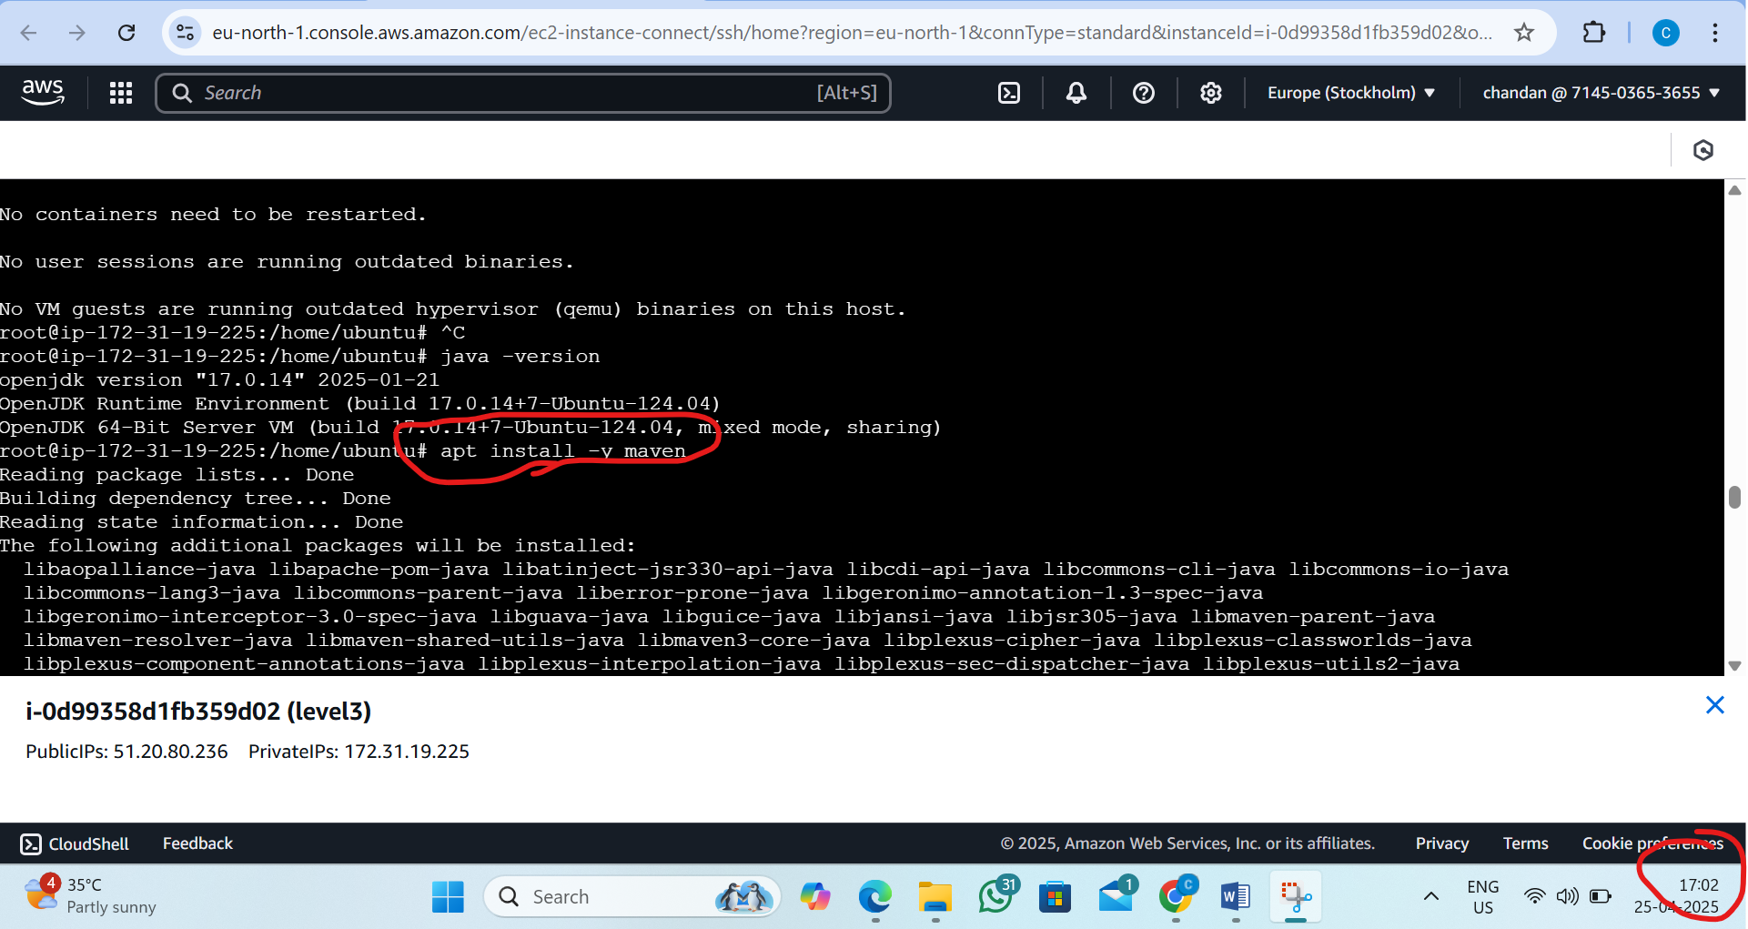

Step6:Maven is installed
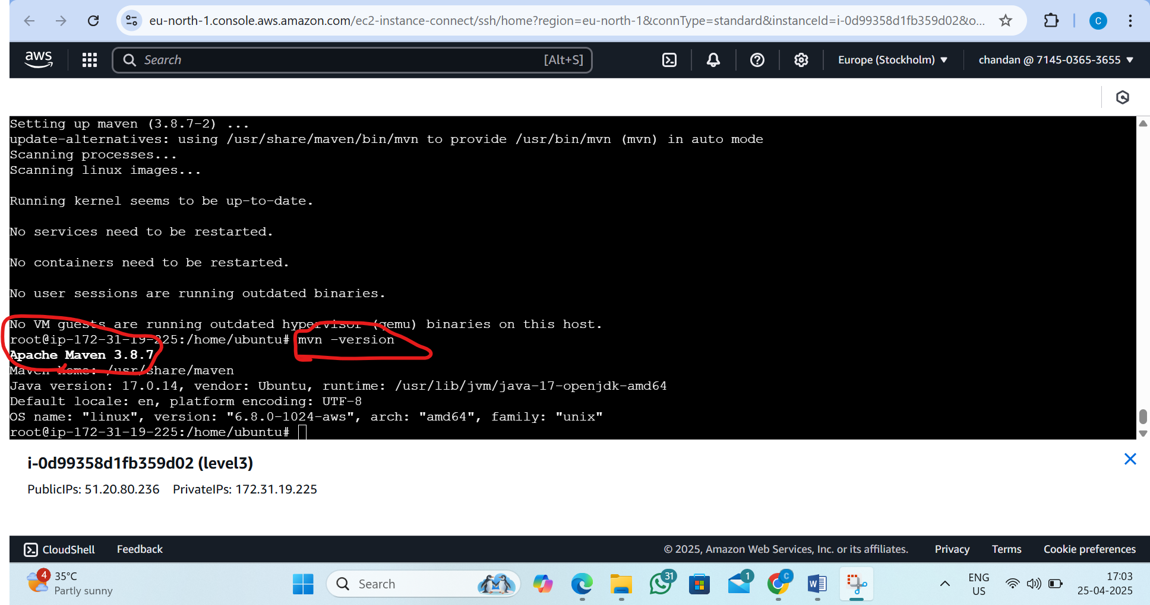

Step7:Install the git version
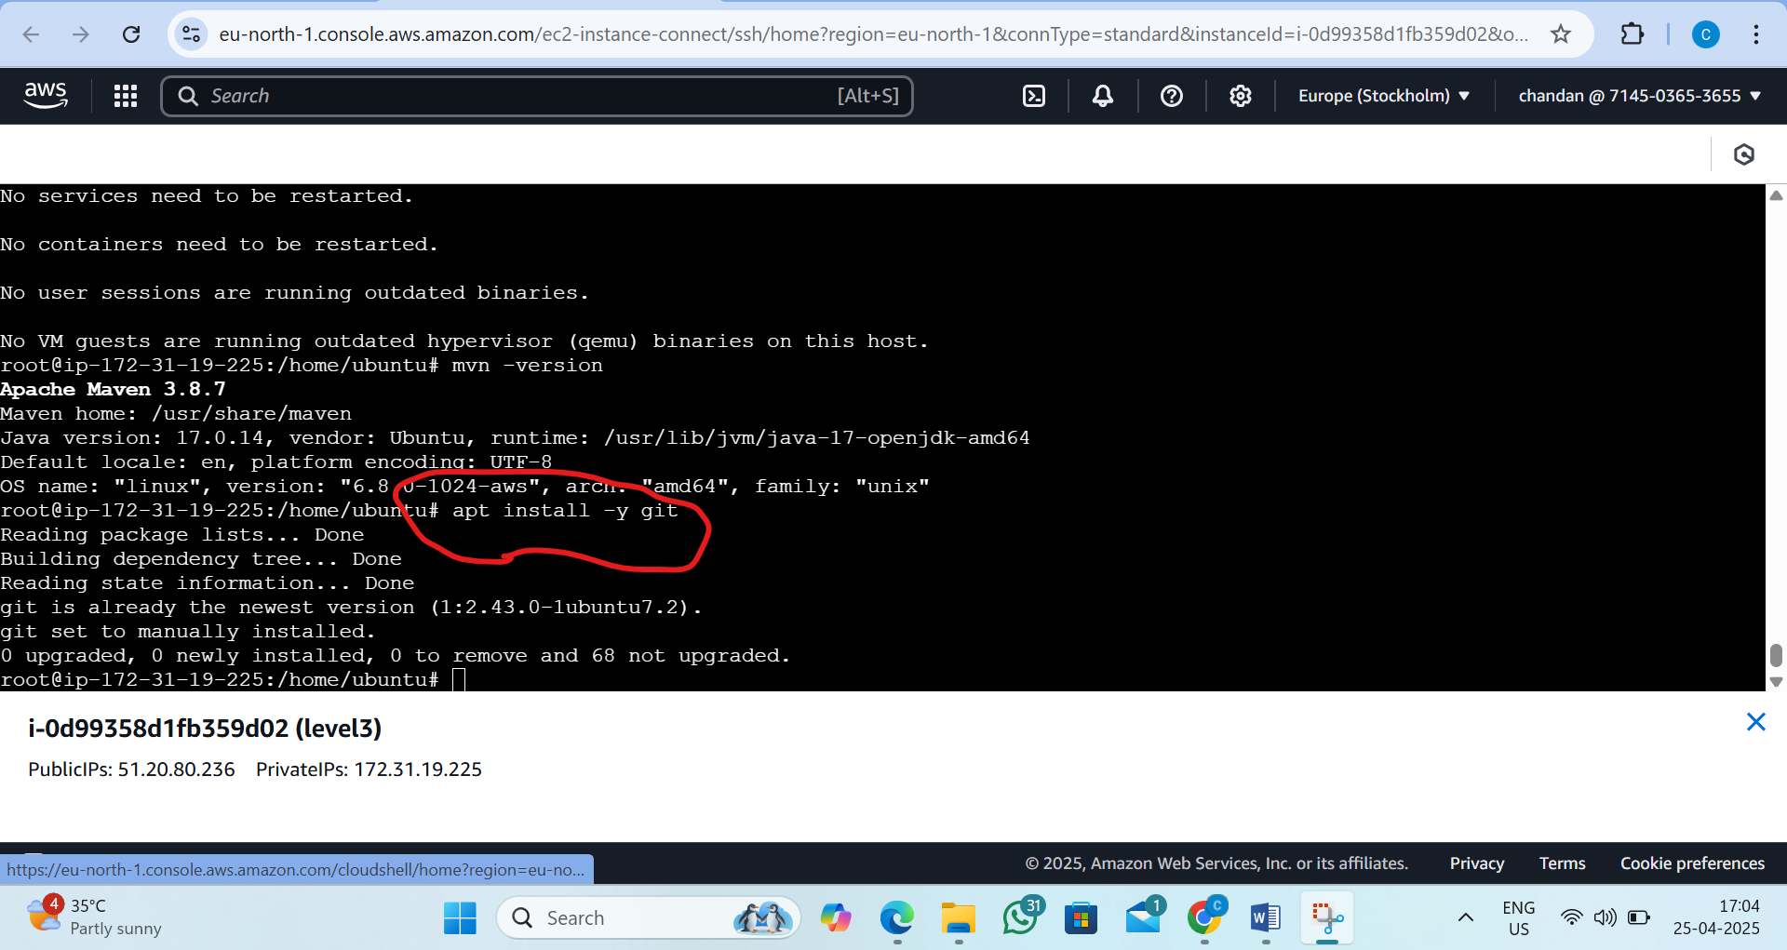

Step8:Git version is installed
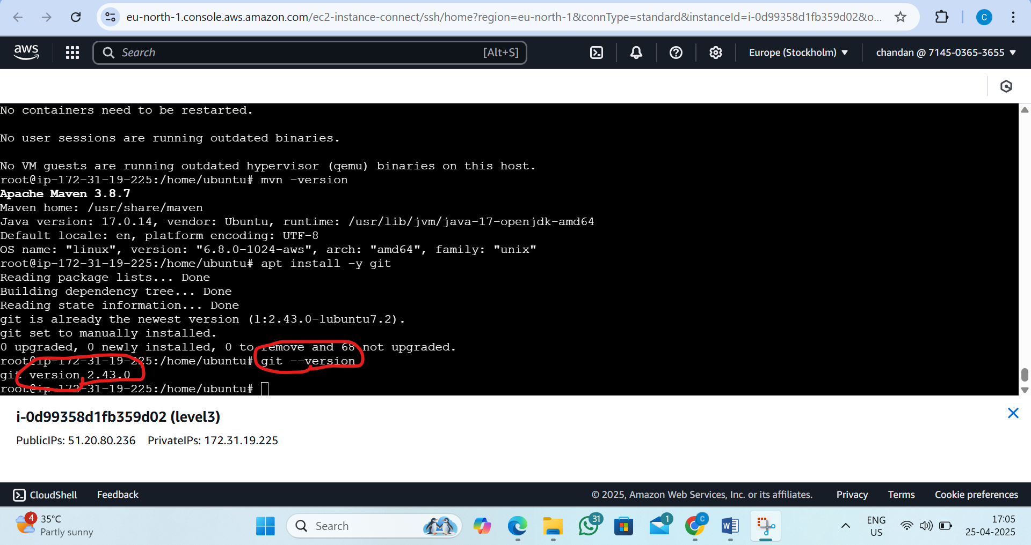

5. L5 - Install Tomcat web application server in AWS EC2 Ubuntu Instance and access Tomcat using a web browser
Step 1 :Create the security group
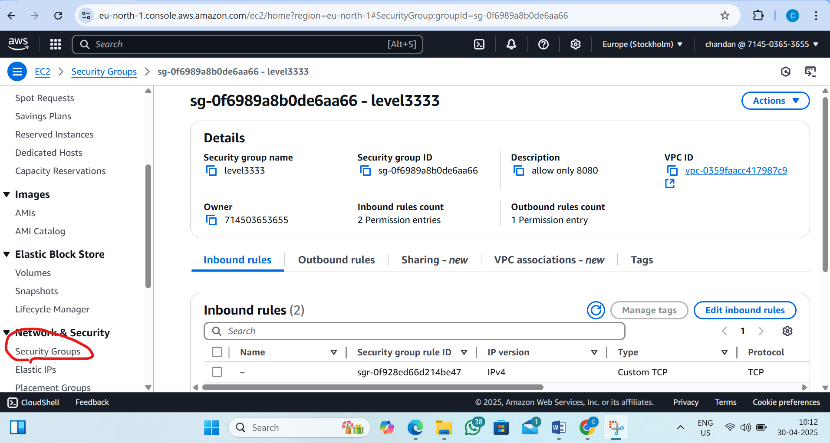
Step 2 :Add inbound rules in security group
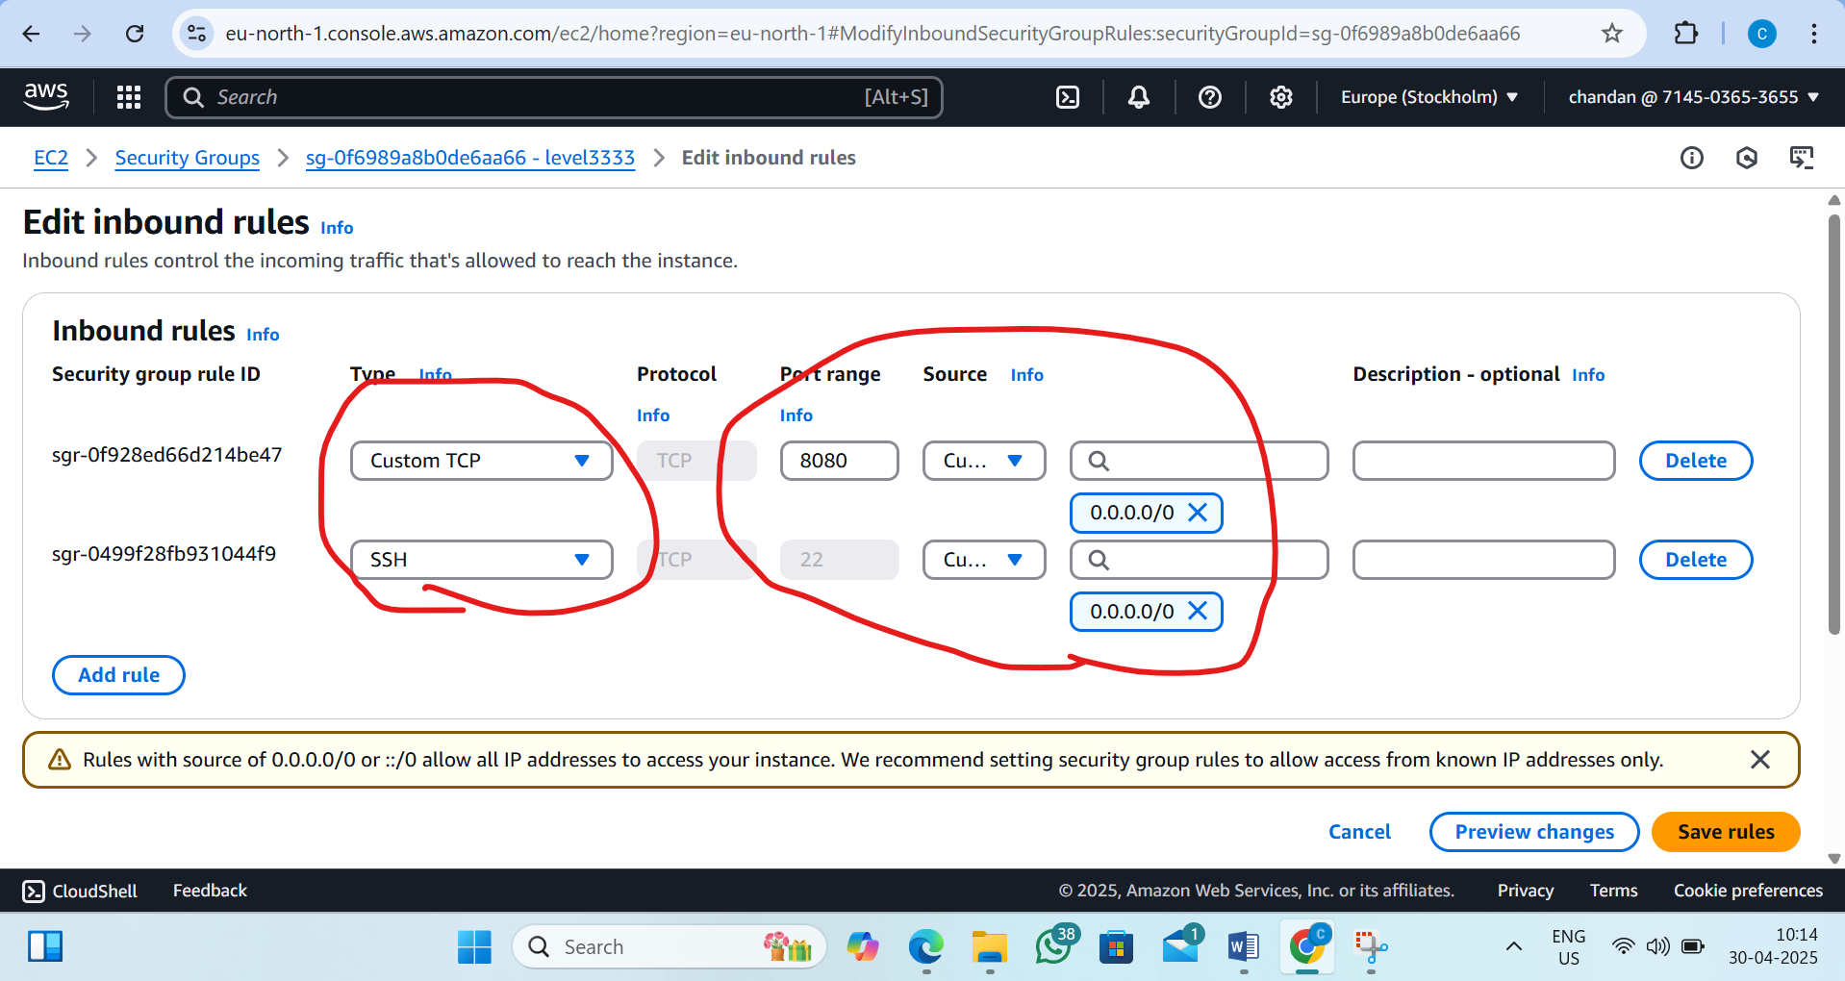

Step3:Create Ec2 insatnce
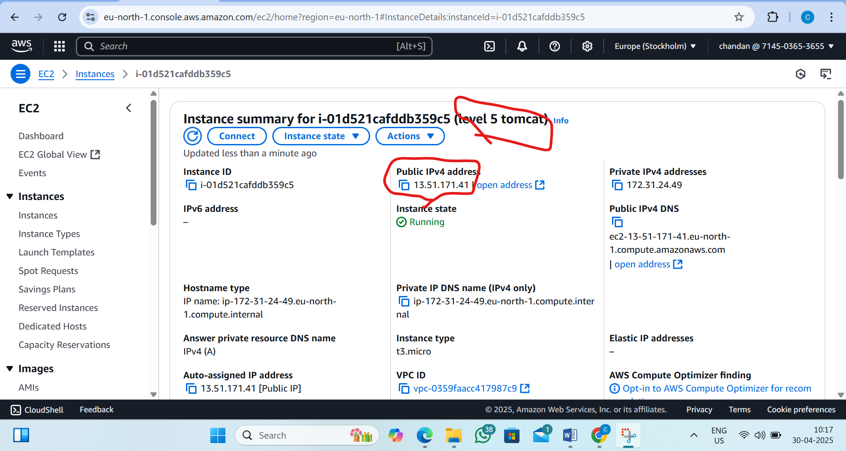

Step4:Connect Ec2 instance
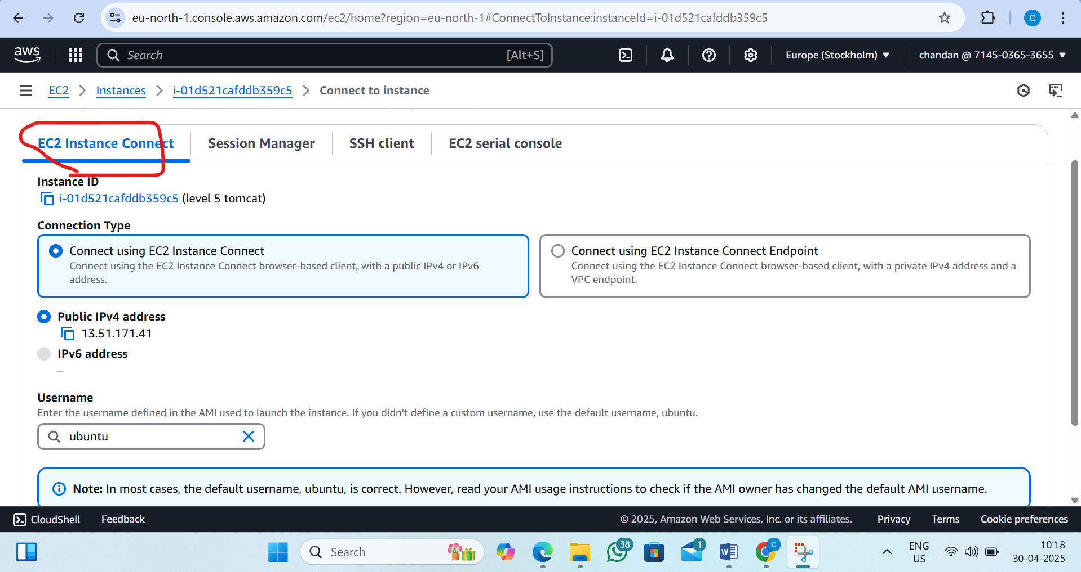

Step5:Server is lunched
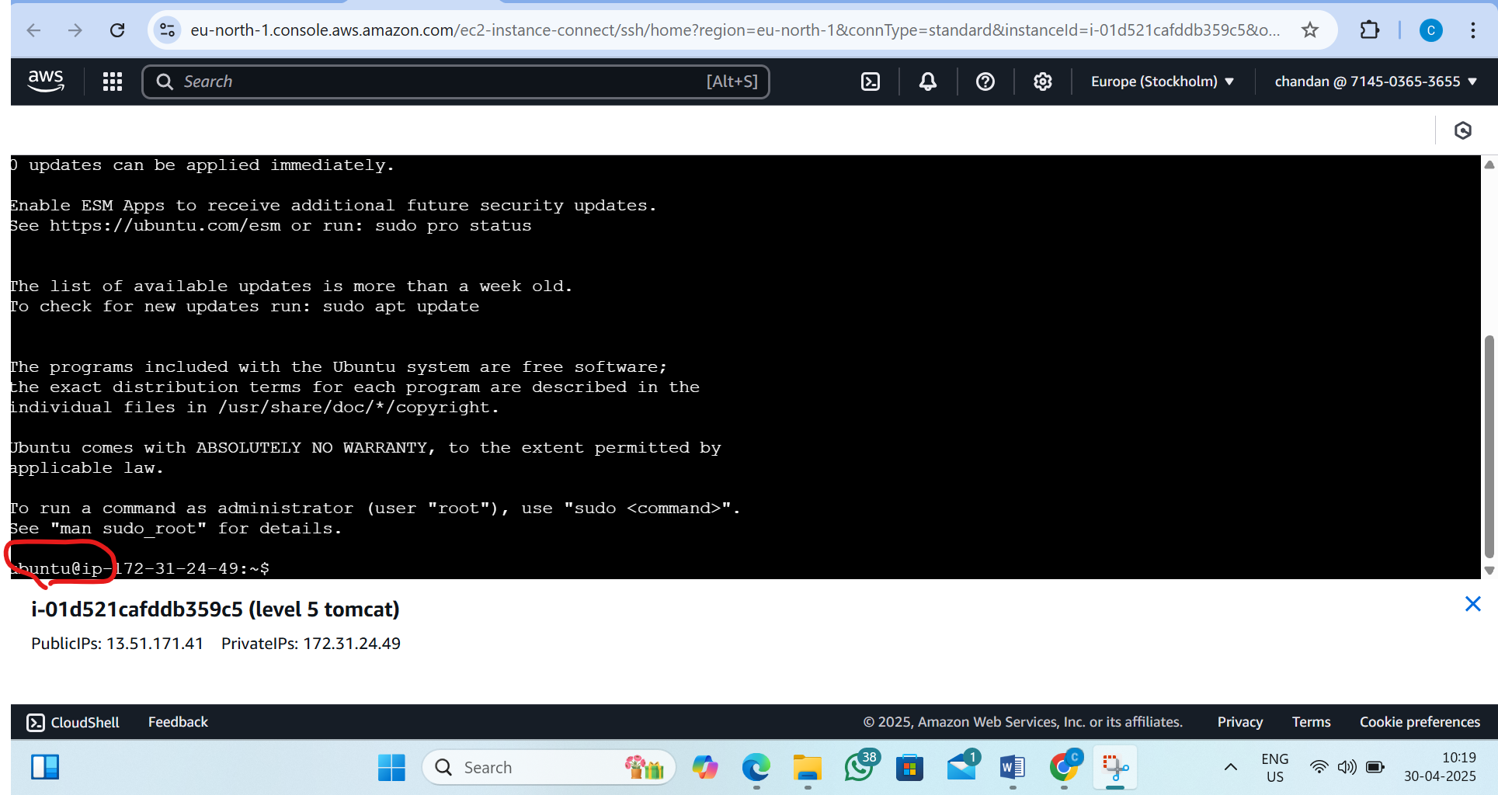
Step6:Install the java 17 version
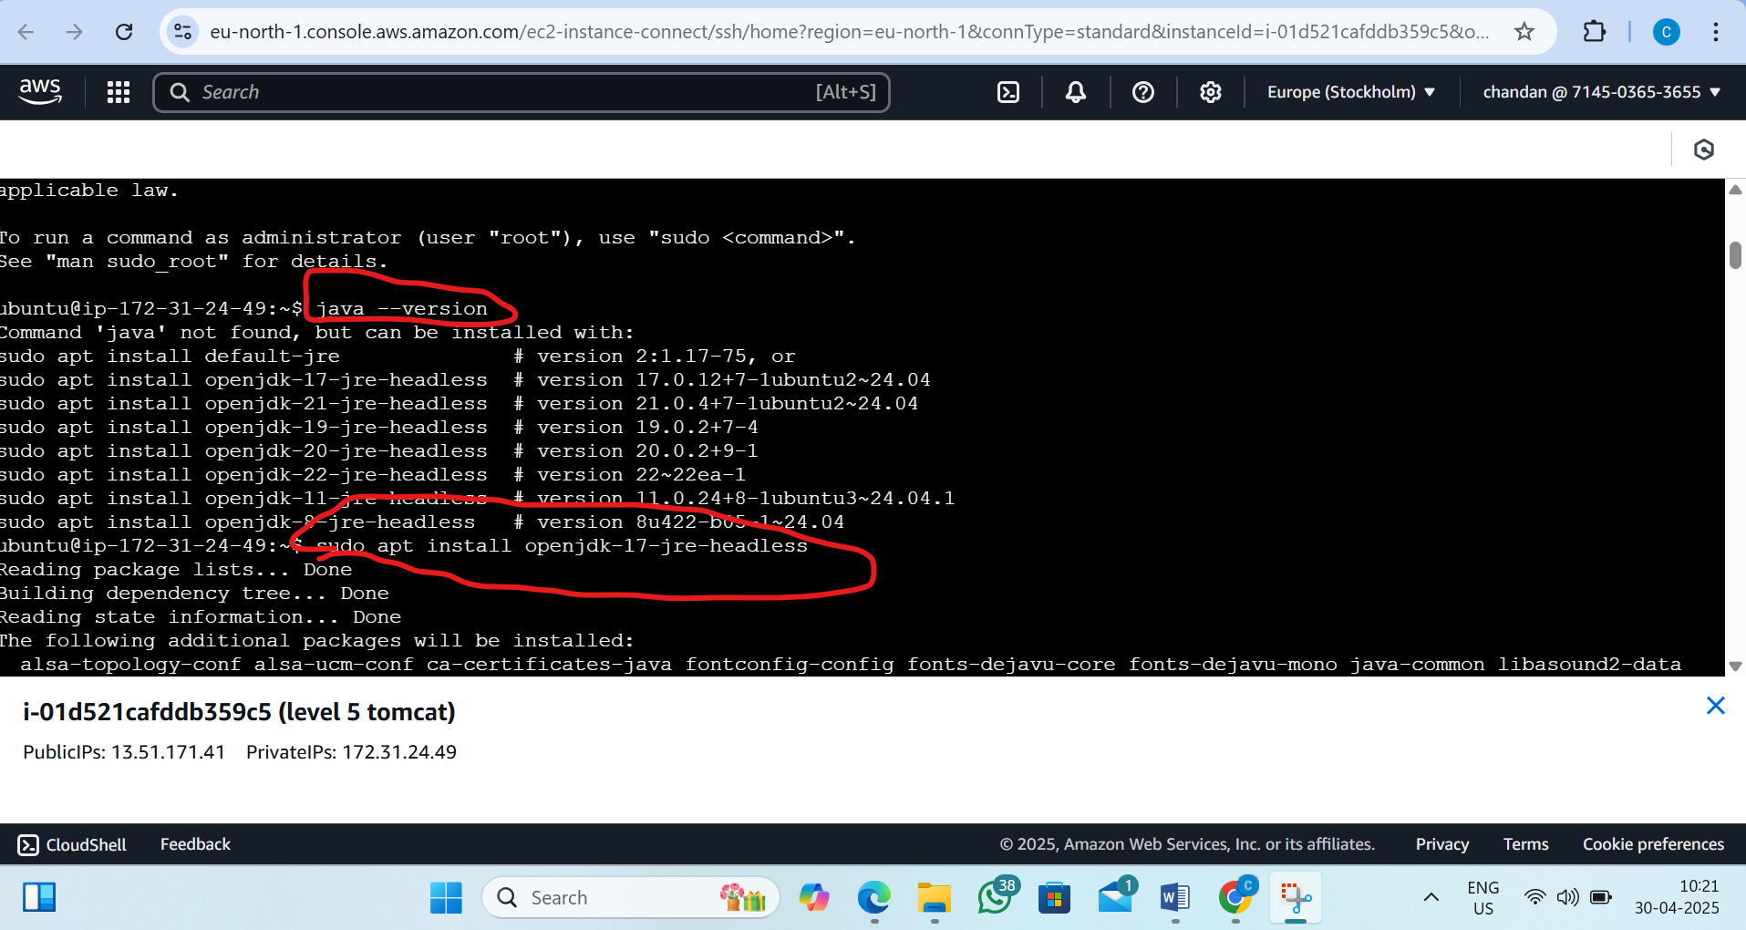

Step7:Java 17 version is installed(validating)
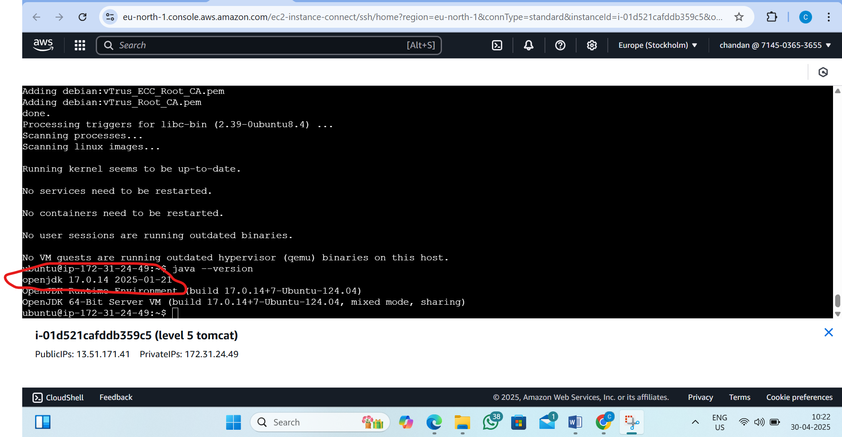

Step8:Chech the tomcat version is there or not (it is not found)
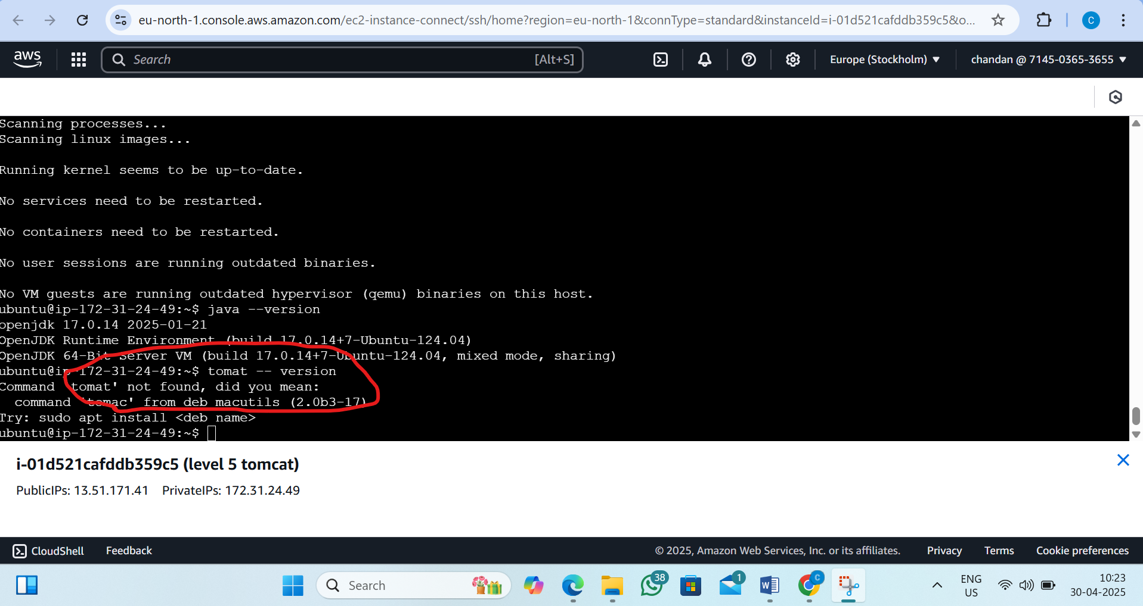

Step9:Go to Tomcat official websit copy the Tomcat 9 tar adderss link
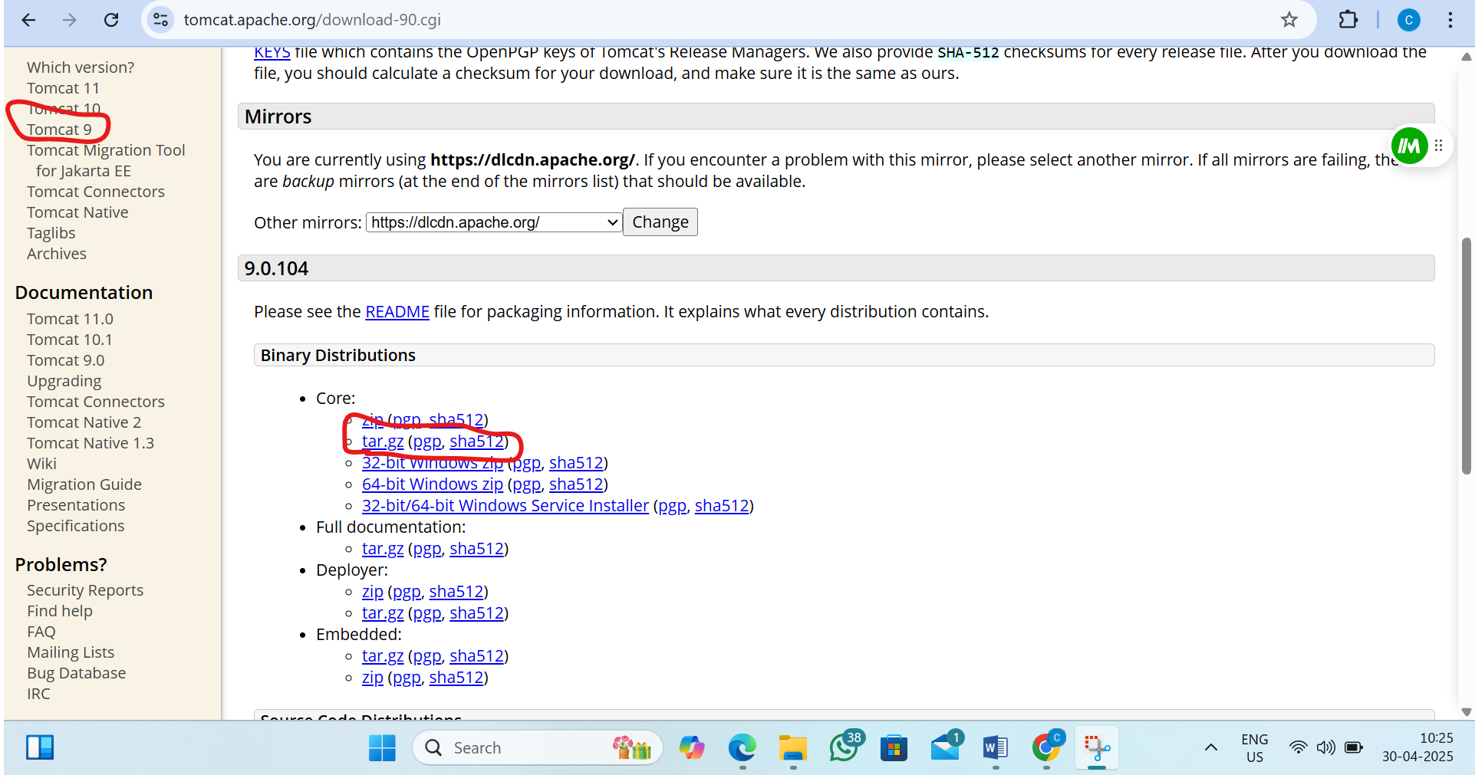

Step10:Paste the link adderss
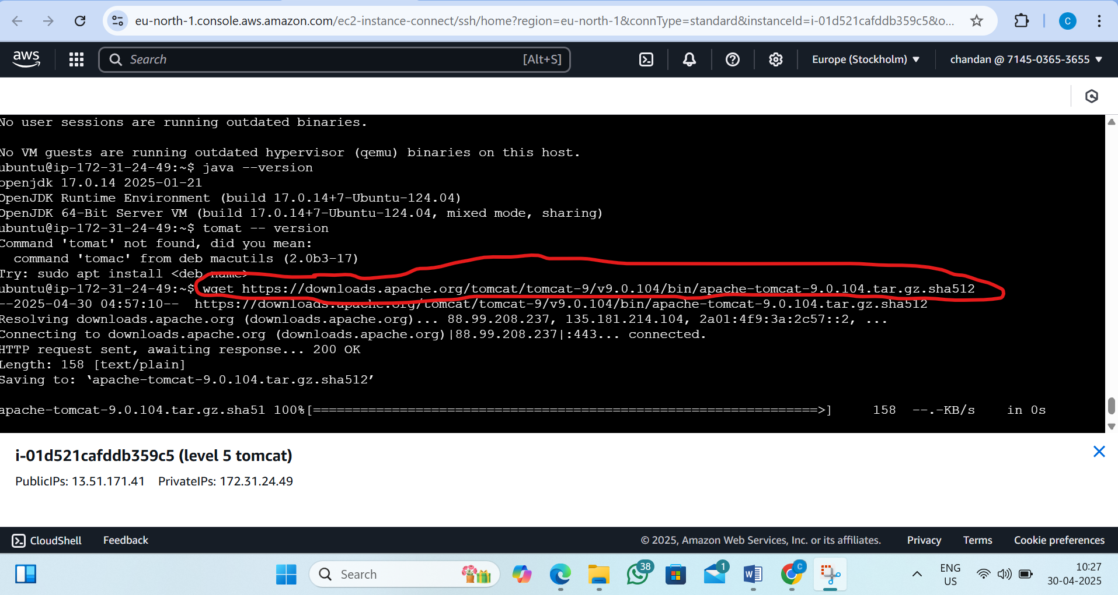

Step11:List the files
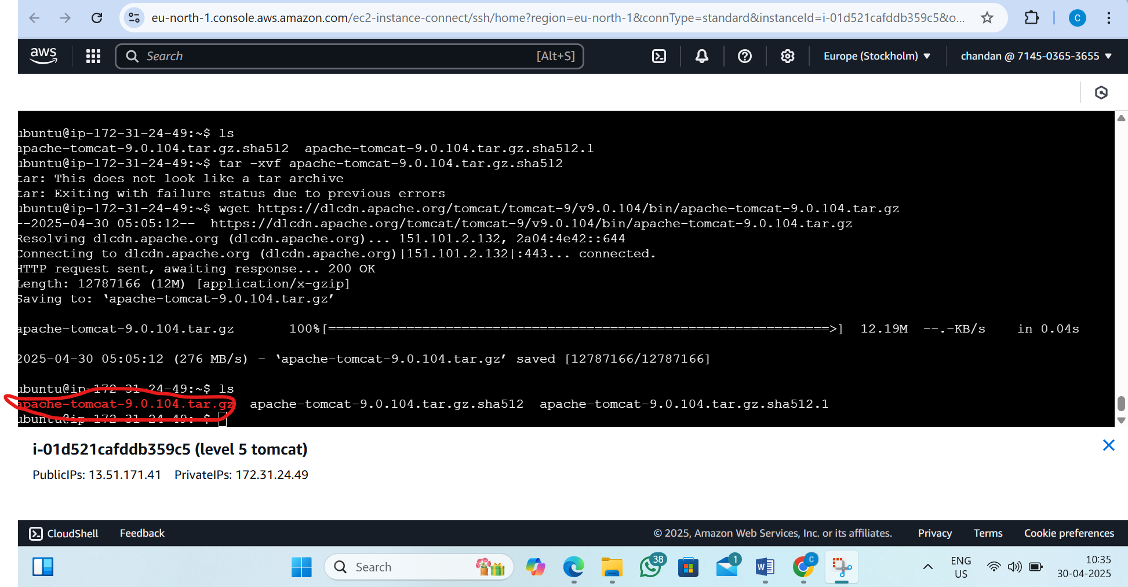

Step12:To Extact tar file (use command tar -xvf )
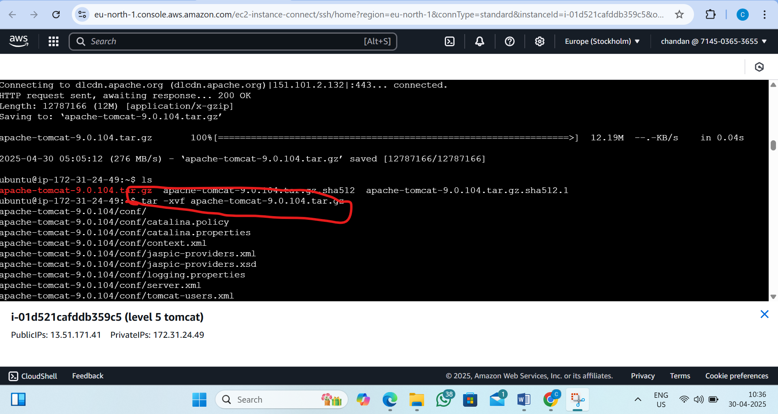

Step13:New directory
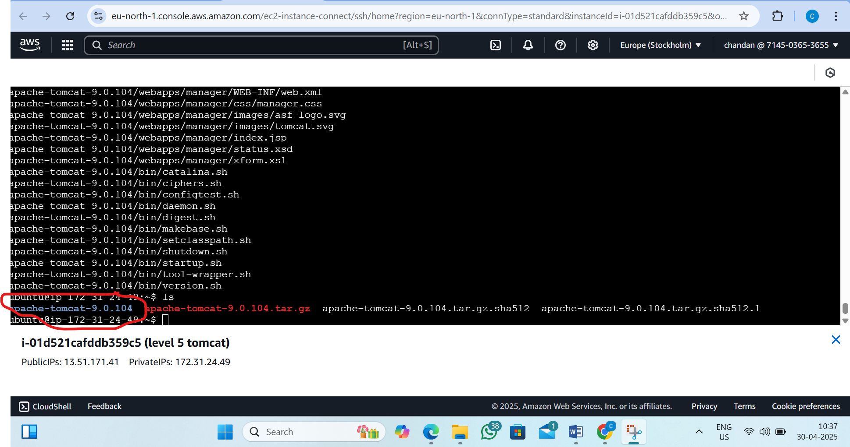
Step14:Change the directory
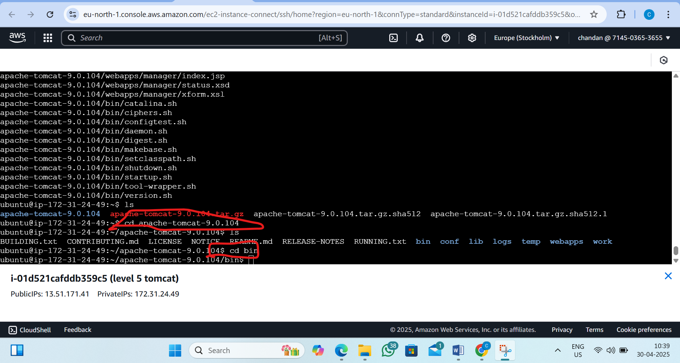

Step15:Now start the Tomcat server
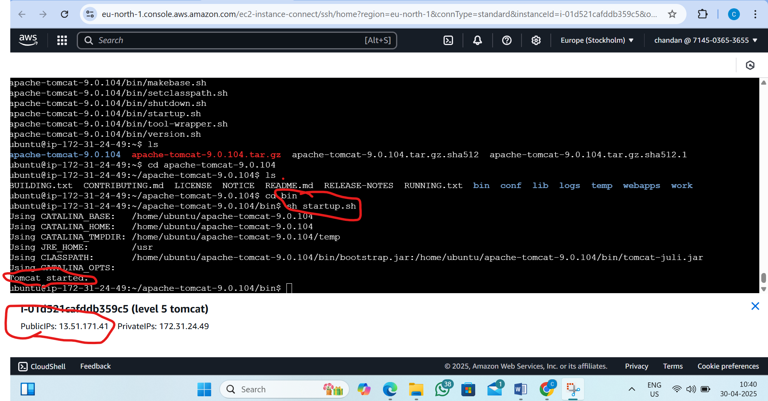

Step16:Copy the public ip and open the Tomcat server
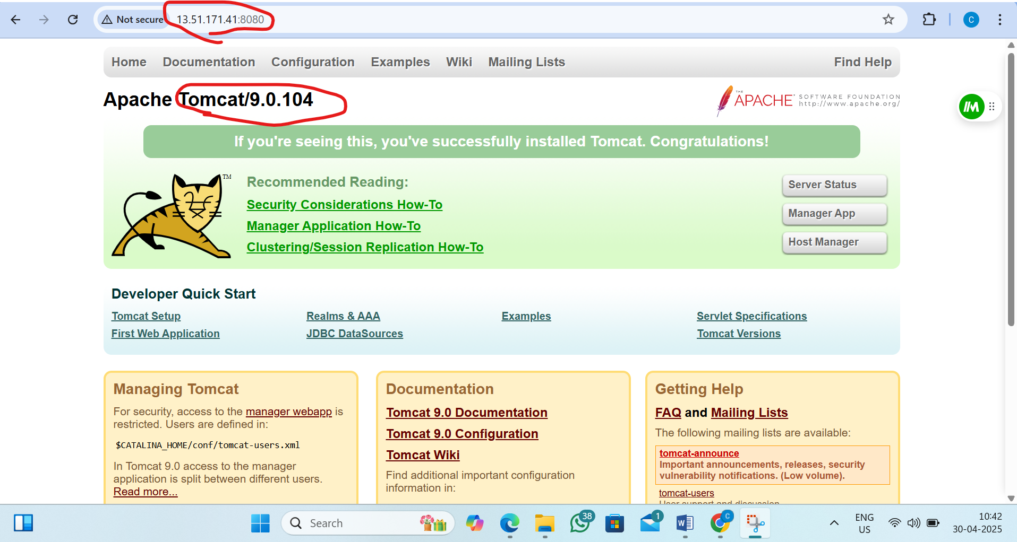

6. L6 - Create S3 Bucket and add folders and files
Step 1 :Create Bucket
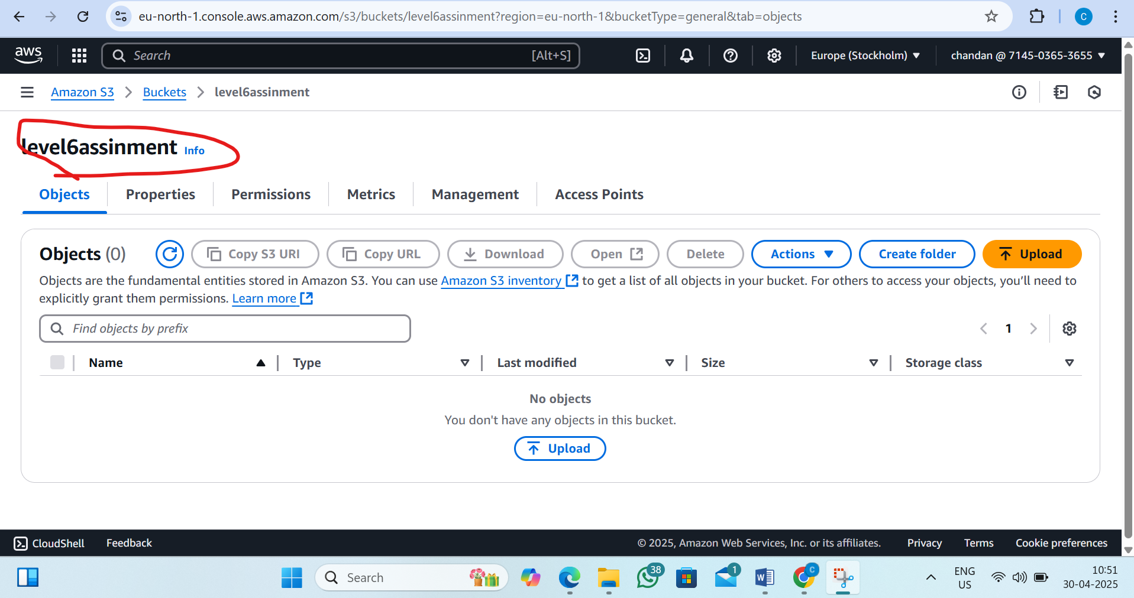

Step 2: Add Folders inside the Bucket
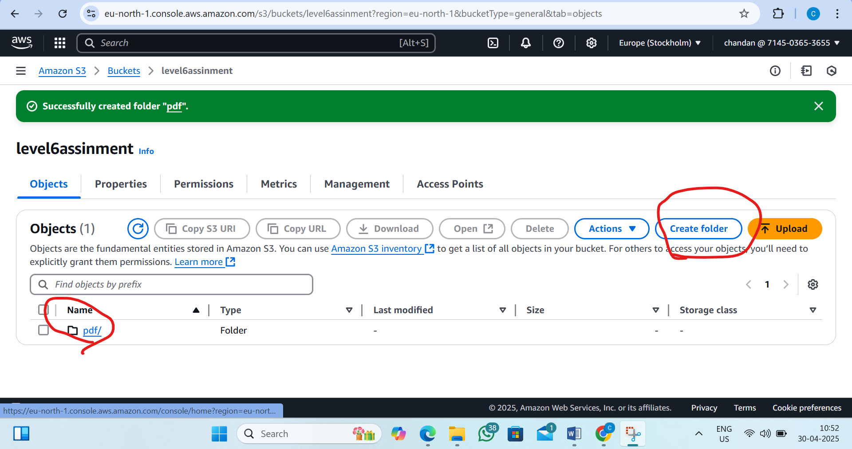

Folder is created
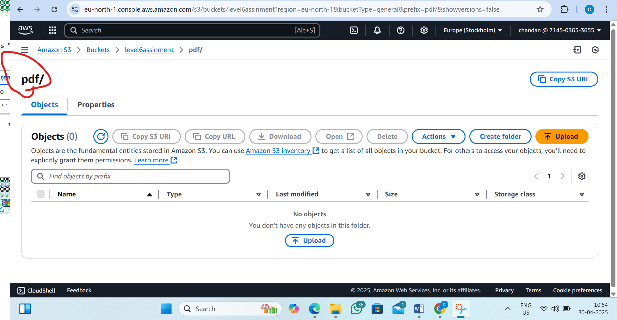

Step 3: Upload Files into the Folders
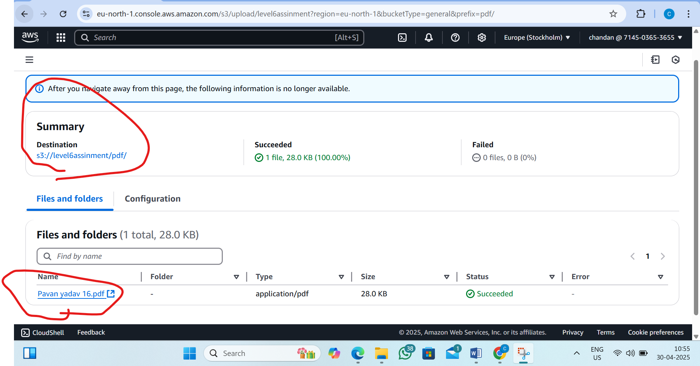

File is uploded
